Customer Churn in Telecommunications: A Statistical Analysis Using IBM SPSS Statistics
SPSS For Research (Final Project)
Shah Md. Tasrif Rahman

Introduction
Customer churn refers to the ending of an ongoing customer relationship with a service provider or business. For any business/service provider, churn can be examined using various information of the customer, their contract details, payment methods, and other related variables. This study uses a modified Telco Customer Churn dataset (Kleon, 2025) to examine patterns associated with whether a customer has left the company.

Research Questions and Hypotheses:
- (Primary): Is customer tenure associated with customer churn?
  - H₀: The distributions of customer tenure are the same for customers who were retained and customers who churned.
  - H₁: The distributions of customer tenure differ between customers who were retained and customers who churned.
- Are contract type and customer churn associated?
  - H₀: Contract type and customer churn are independent.
  - H₁: Contract type and customer churn are not independent, thus are associated.
- Which customer characteristics are associated with the odds of customer churn?
  - H₀: None of the selected customer characteristics is associated with the odds of customer churn, all corresponding regression coefficients are zero.
  - H₁: At least one selected customer characteristic is associated with the odds of customer churn; at least one regression coefficient differs from zero.

Methods
Dataset and Sample
The dataset used in this study was the modified Telco Customer Churn Dataset obtained from Kaggle (Kleon, 2025). The raw CSV file contained 7043 customer records with 21 variables, including demographic characteristics, service variables, contract and payment information, continuous charge variables, and the binary churn outcome. Variable definitions and measurement levels are provided in Appendix A (Table A1).
This dataset was chosen because it meets all the criteria given for this project which are as follows:
- At least 6 usable variables, with a mix of categorical and continuous types.
- At least 150 cases (rows).
- Contains one binary/categorical outcome suitable for logistic regression, and at least one continuous variable suitable for a t-test/ANOVA and for correlation or linear regression.
- Publicly available and properly citable. Should not contain any personally identifying information such as phone number, name, etc.
- Some realistic data issues to clean (missing values, inconsistent coding, or duplicates) that will help demonstrate data cleaning skill.

Data Management and Cleaning
The raw CSV file was imported directly into SPSS and preserved as the source data. During the initial inspection, blank string values in gender, Partner, InternetService, and StreamingTV were not initially treated by SPSS as missing observations. These blank strings were therefore declared as user-missing values in SPSS. Numeric missing values already imported as system-missing were retained.
The dataset was checked for duplicate observations. No duplicate cases were identified, thus no records were removed for duplication.
All 7,043 observations were retained in the final dataset, individual analyses used the available cases required for their respective variables. Information about missing values is provided in Appendix A (Table A2).
The variable “Churn” was recoded into a binary analysis variable, with 0 representing retained customers and 1 representing churned customers. Categorical variables were defined with appropriate value labels and measurement levels.

Statistical Analysis
Descriptive statistics were produced for the available variables. Categorical variables were summarized using frequencies and percentages, whereas continuous variables were summarized using the mean, standard deviation, median, minimum, and maximum.
For the first or primary research question, customer tenure distributions were examined within churn groups using histograms, Q-Q plots, and normality tests. Because the distributions departed from normality, a Mann-Whitney U test was used to compare tenure between retained and churned customers.
For the second research question, a Pearson chi-square test of independence was used to examine the association between contract type and customer churn. Cramer's V was reported as effect-size measure, and expected cell counts were checked.
For the third research question, binary logistic regression was used with Churn as the dependent/target variable. Churn was recoded into a usable binary variable for this process. Predictors were selected based on their relevance to the target variable and their representation of different aspects of the customer relationship. The initial model included the predictors: tenure, MonthlyCharges, Contract, TechSupport, InternetService, and PaymentMethod. This model was specified with 11 expected predictor degrees of freedom. SPSS identified redundancy among the categorical predictors and reduced the estimable degrees of freedom to 10. Two reduced models were therefore examined to solve this issue, retaining either InternetService or TechSupport. The model retaining InternetService showed evidence of lack of fit according to the Hosmer-Lemeshow test, χ²(8) = 17.656, p = .024. The model retaining TechSupport showed no statistically significant evidence of lack of fit, χ²(8) = 11.632, p = .168. The latter was therefore selected as the final model. The final binary logistic regression model included the predictors: tenure, MonthlyCharges, PaymentMethod, Contract, and TechSupport.
Relevant graphs were produced accordingly to support the research questions.

Results
Table 1
Descriptive Statistics
Variable | Category | n | % | Mean (SD) | Median | Minimum | Maximum
Customer gender | Female | 3,091 | 49.12
 | Male | 3,202 | 50.88
Indicates if the customer is a senior citizen (0 = No, 1 = Yes) | No | 5,901 | 83.79
 | Yes | 1,142 | 16.21
Whether the customer has a partner | No | 3,115 | 51.55
 | Yes | 2,928 | 48.45
Whether the customer has dependents | No | 4,933 | 70.04
 | Yes | 2,110 | 29.96
Number of months the customer has stayed with the company |  |  |  | 32.5 (24.5) | 29.0 | 0.0 | 72.0
Whether the customer has phone service | No | 682 | 9.68
 | Yes | 6,361 | 90.32
Whether the customer has multiple lines | No | 3,390 | 48.13
 | No phone service | 682 | 9.68
 | Yes | 2,971 | 42.18
Customer's internet service provider | DSL | 2,082 | 34.45
 | Fiber optic | 2,660 | 44.02
 | No | 1,301 | 21.53
Whether the customer has online security | No | 3,498 | 49.67
 | No internet service | 1,526 | 21.67
 | Yes | 2,019 | 28.67
Whether the customer has online backup | No | 3,088 | 43.84
 | No internet service | 1,526 | 21.67
 | Yes | 2,429 | 34.49
Whether the customer has device protection | No | 3,095 | 43.94
 | No internet service | 1,526 | 21.67
 | Yes | 2,422 | 34.39
Whether the customer has tech support | No | 3,473 | 49.31
 | No internet service | 1,526 | 21.67
 | Yes | 2,044 | 29.02
Whether the customer has streaming TV | No | 2,199 | 39.67
 | No internet service | 1,198 | 21.61
 | Yes | 2,146 | 38.72
Whether the customer has streaming movies | No | 2,785 | 39.54
 | No internet service | 1,526 | 21.67
 | Yes | 2,732 | 38.79
Type of contract | Month-to-month | 3,875 | 55.02
 | One year | 1,473 | 20.91
 | Two year | 1,695 | 24.07
Whether the customer uses paperless billing | No | 2,872 | 40.78
 | Yes | 4,171 | 59.22
Payment method | Bank transfer (automatic) | 1,544 | 21.92
 | Credit card (automatic) | 1,522 | 21.61
 | Electronic check | 2,365 | 33.58
 | Mailed check | 1,612 | 22.89
Monthly charges |  |  |  | 64.88 (30.10) | 70.55 | 18.25 | 118.60
Total charges to date |  |  |  | 2283.30 (2266.77) | 1397.48 | 18.80 | 8684.80
Whether the customer has left the company | Customer retained | 5,174 | 73.46
 | Customer churned | 1,869 | 26.54

Note. N = 7,043. SD = standard deviation.

Table 2
Tests of Normality for Customer Tenure by Churn Status
Customer Status | n | Kolmogorov-Smirnov D | p | Shapiro-Wilk W | p
Customer retained | 3,352 | .094 | < .001 | .917 | < .001
Customer churned | 1,191 | .185 | < .001 | .831 | < .001

Note. Dependent variable: Number of months the customer has stayed with the company. The Kolmogorov-Smirnov test uses the Lilliefors significance correction. For both retained and churned customers, the Kolmogorov-Smirnov and Shapiro-Wilk tests were statistically significant (p < .001), indicating deviations from normality.

Table 3
Mann-Whitney U Test Comparing Customer Tenure by Churn Status
Churn status | n | Mean rank
Customer retained | 3,352 | 2,546.27
Customer churned | 1,191 | 1,500.08
Mann–Whitney U |  | 1,076,759
z |  | −23.656
p |  | < .001

Note. The dependent variable was customer tenure (number of months the customer stayed with the company), and the grouping variable was churn status.
Table 4
Association Between Contract Type and Customer Churn Status
Customer Status | Month-to-month | One year | Two year | Total
Customer retained n (%) | 2,220 (57.3) | 1,307 (88.7) | 1,647 (97.2) | 5,174 (73.5)
Customer churned n (%) | 1,655 (42.7) | 166 (11.3) | 48 (2.8) | 1,869 (26.5)
Total n (%) | 3,875 (100.0) | 1,473 (100.0) | 1,695 (100.0) | 7,043 (100.0)

Test Statistic | Value
Pearson χ² | 1184.597
df | 2
N | 7,043
p | < .001
Cramer's V | .410

Note. Customer churn status and contract type were significantly associated, χ²(2, N = 7,043) = 1184.597, p < .001, and Cramer's V = .410.

Table 5
Binary Logistic Regression Model Statistics
Statistic | Value
Omnibus χ² (df) | 1291.125 (9), p < .001
-2 Log Likelihood | 3936.103
Cox & Snell R² | .247
Nagelkerke R² | .362
Hosmer-Lemeshow χ² (df) | 11.632 (8), p = .168
Classification Accuracy | 79.2%

Note. χ² = chi-square test statistic. Cox & Snell and Nagelkerke values represent pseudo-R² measures. A non-significant Hosmer-Lemeshow test indicates adequate model fit. Classification accuracy represents the percentage of cases correctly classified using a cutoff value of .500. Classification performance was higher for customers who did not churn (89.6%) than for customers who churned (49.9%).

Table 6
Regression Coefficients
Predictor | B | SE | Wald χ² | df | p | OR | 95% CI for OR
Number of months the customer has stayed with the company | -0.029 | 0.003 | 133.258 | 1 | < .001 | 0.971 | [0.966, 0.976]
Monthly charges | 0.022 | 0.002 | 95.177 | 1 | < .001 | 1.022 | [1.017, 1.026]
Payment method (Reference: Bank transfer [automatic]) |  |  | 32.633 | 3 | < .001
Credit card (automatic) | -0.049 | 0.137 | 0.127 | 1 | .721 | 0.952 | [0.728, 1.246]
Electronic check | 0.412 | 0.112 | 13.483 | 1 | < .001 | 1.510 | [1.212, 1.881]
Mailed check | -0.120 | 0.136 | 0.781 | 1 | .377 | 0.887 | [0.679, 1.158]
Type of contract (Reference: Month-to-month) |  |  | 95.580 | 2 | < .001
One year | -0.869 | 0.124 | 49.299 | 1 | < .001 | 0.419 | [0.329, 0.534]
Two year | -1.797 | 0.212 | 71.909 | 1 | < .001 | 0.166 | [0.109, 0.251]
Whether the customer has tech support (Reference: No) |  |  | 26.076 | 2 | < .001
No internet service | -0.466 | 0.174 | 7.142 | 1 | .008 | 0.628 | [0.446, 0.883]
Yes | -0.470 | 0.102 | 21.078 | 1 | < .001 | 0.625 | [0.511, 0.764]
Constant | -1.277 | 0.184 | 47.933 | 1 | < .001 | 0.279

Note. B = logistic regression model coefficient; SE = standard error; OR = odds ratio (Exp(B)); CI = confidence interval. Reference categories were Bank transfer (automatic) for payment method, Month-to-month for contract type, and No for tech support.

Table 7
Binary Logistic Regression Model Selection
Model | Modification | H-L test χ² | df | p | Model Status
Initial model | None | 5.454 | 8 | .708 | Redundancy detected in predictors
InternetService retained | TechSupport removed | 17.656 | 8 | .024 | Evidence of lack of fit
TechSupport retained | InternetService removed | 11.632 | 8 | .168 | Final model retained

Note. Model selection was based on redundancy diagnostics and Hosmer-Lemeshow goodness-of-fit tests. The final model retained the variables: tenure, MonthlyCharges, PaymentMethod, Contract, and TechSupport. A non-significant Hosmer-Lemeshow test indicated adequate model fit.

Figure 1
Distribution of customer churn status
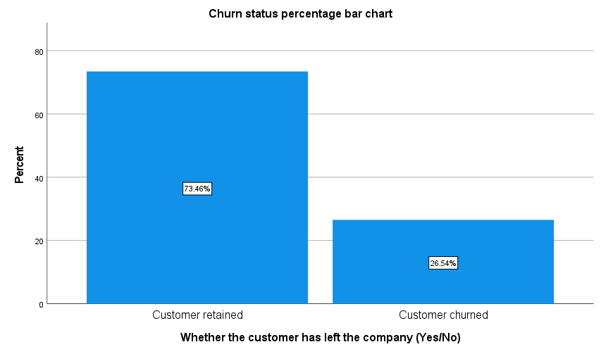
Figure 2
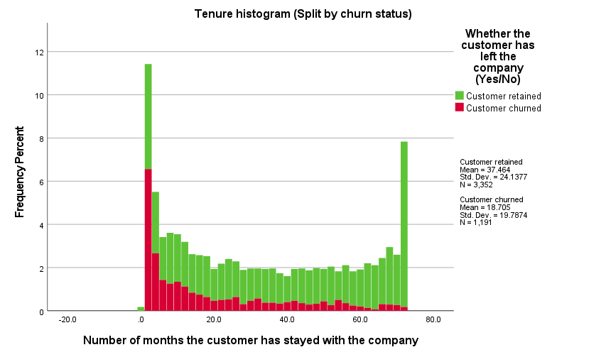
Distribution of customer tenure by split by churn status

Figure 3
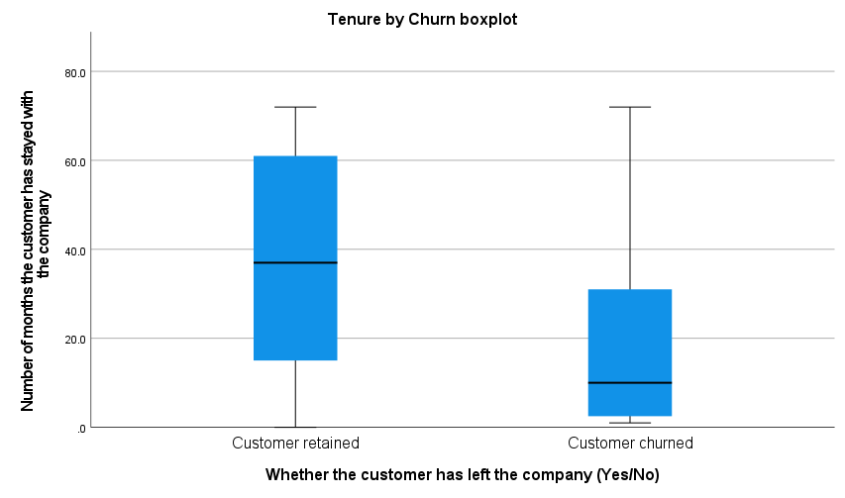
Customer tenure boxplot by churn status
Figure 4
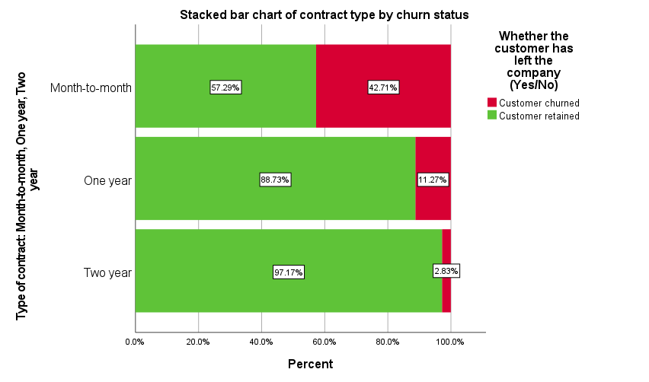
Churn status by contract type, expressed as percentages within each contract category

Figure 5
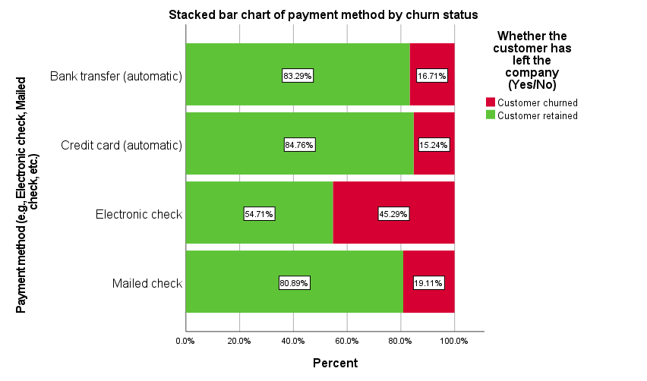
Churn status by payment method, expressed as percentages within each payment category
Figure 6
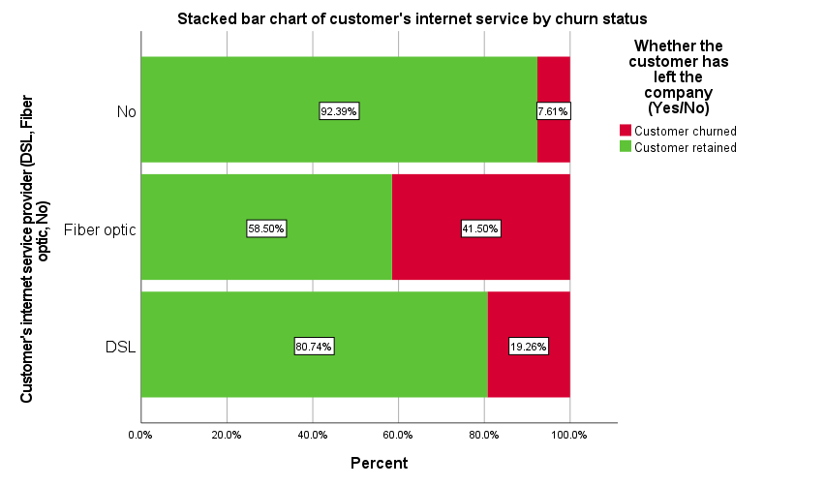
Churn status by internet service type, expressed as percentages within each service category

Discussion
This study examined customer churn in a telecommunications company dataset using descriptive statistics, non-parametric testing, chi-square testing, and binary logistic regression. Three research questions were used to investigate whether customer tenure and contract type were associated with customer churn and whether selected customer characteristics were associated with the odds of customer churn.
The first research question examined the association between customer tenure and churn. The Mann-Whitney U test showed a statistically significant difference in tenure distributions between retained and churned customers. This finding suggests that churned customers had substantially shorter tenure distributions than retained customers.
The second research question examined the relationship between contract type and churn. A significant association was found between the two variables, χ²(2, N = 7,043) = 1184.597, p < .001, Cramer’s V = .410. The observed churn rates differed considerably across contract categories: 42.7% among month-to-month customers, 11.3% among one-year customers, and 2.8% among two-year customers. These results indicate that churn status varied substantially across contract types. However, because this analysis is observational, these results indicate an association rather than a causal effect of contract type on churn.
The third research question examined several customer characteristics associated with the odds of churn using binary logistic regression. The final model included tenure, MonthlyCharges, PaymentMethod, Contract, and TechSupport and was statistically significant, χ²(9) = 1291.125, p < .001. The model had a Nagelkerke pseudo-R² of .362, while the Hosmer-Lemeshow test was non-significant, χ²(8) = 11.632, p = .168, providing no evidence of lack of fit. Tenure, MonthlyCharges, contract type, TechSupport, and one PaymentMethod (Electronic check) showed statistically significant associations with odds of customer churn. In particular, longer tenure was associated with lower odds of churn, whereas higher MonthlyCharges were associated with higher odds of churn. Compared with month-to-month contracts, both one-year and two-year contracts were associated with lower estimated odds of churn. And compared to Bank transfer (automatic), only the Electronic check category was associated with significantly higher estimated odds of churn.
The findings from these three research questions are broadly consistent with one another. The descriptive statistics and inferential results indicate that customer relationship duration and contractual characteristics are closely related to churn status, while the logistic regression shows that several characteristics remain associated with churn when considered together.
Some limitations of this study are as follows:
- The regression analysis included only 4,543 of the 7,043 observations because of missing tenure values, meaning that 35.5% of the records were not included in the multivariable regression analysis, which may affect the representativeness of the regression estimates.
- The dataset contains intentionally introduced missing values by the dataset author, so its data structure may not represent naturally occurring customer data.
- Although the binary logistic regression model correctly classified 79.2% of cases overall, it correctly identified retained customers more often (89.6%) than churned customers (49.9%). Therefore, overall accuracy alone does not represent performance equally across the two outcome groups.

Overall, the analysis provides evidence that customer tenure, contract type, services, billing, and payment characteristics are associated with customer churn in this dataset.

References
Kleon, A. (2025, July 18). 📊 Telco Customer Churn Dataset. Kaggle. Telco Customer Churn Dataset. https://www.kaggle.com/datasets/jethwaaatmik/telco-customer-churn-dataset

Appendix A
Additional Tables
Table A1
Dataset Variables and Measurement Levels
Variable | Description | Unit | Measure
customerID | Unique identifier for each customer |  | Nominal
gender | Customer gender: Male/Female |  | Nominal
SeniorCitizen | Indicates if the customer is a senior citizen (0 = No, 1 = Yes) |  | Nominal
Partner | Whether the customer has a partner |  | Nominal
Dependents | Whether the customer has dependents |  | Nominal
tenure | Number of months the customer has stayed with the company | Months | Scale
PhoneService | Whether the customer has phone service |  | Nominal
MultipleLines | Whether the customer has multiple lines |  | Nominal
InternetService | Customer's internet service provider (DSL, Fiber optic, No) |  | Nominal
OnlineSecurity | Whether the customer has online security |  | Nominal
OnlineBackup | Whether the customer has online backup |  | Nominal
DeviceProtection | Whether the customer has device protection |  | Nominal
TechSupport | Whether the customer has tech support |  | Nominal
StreamingTV | Whether the customer has streaming TV |  | Nominal
StreamingMovies | Whether the customer has streaming movies |  | Nominal
Contract | Type of contract: Month-to-month, One year, Two year |  | Nominal
PaperlessBilling | Whether the customer uses paperless billing |  | Nominal
PaymentMethod | Payment method (e.g., Electronic check, Mailed check, etc.) |  | Nominal
MonthlyCharges | Monthly charges | USD | Scale
TotalCharges | Total charges to date | USD | Scale
Churn | Whether the customer has left the company (Yes/No) |  | Nominal

Table A2
Missing Data Summary
Variable | Missing (n) | Missing (%)
gender | 750 | 10.65
Partner | 1,000 | 14.20
tenure | 2,500 | 35.50
InternetService | 1,000 | 14.20
StreamingTV | 1,500 | 21.30
MonthlyCharges | 1,500 | 21.30
TotalCharges | 11 | 0.16

Note. Missing (%) represents the percentage of observations with missing data for each variable.

Appendix B
SPSS Output
* Encoding: UTF-8.

* /Step-1: Data loading/

PRESERVE.
SET DECIMAL DOT.

GET DATA /TYPE=TXT
/FILE="E:\Statistical Softwares\SPSS\CUSPC-SPSS\Assignments\Final Project\telco_data.csv"
/ENCODING='UTF8'
/DELIMITERS=","
/QUALIFIER='"'
/ARRANGEMENT=DELIMITED
/FIRSTCASE=2
/DATATYPEMIN PERCENTAGE=95.0
/VARIABLES=
customerID AUTO
gender AUTO
SeniorCitizen AUTO
Partner AUTO
Dependents AUTO
tenure AUTO
PhoneService AUTO
MultipleLines AUTO
InternetService AUTO
OnlineSecurity AUTO
OnlineBackup AUTO
DeviceProtection AUTO
TechSupport AUTO
StreamingTV AUTO
StreamingMovies AUTO
Contract AUTO
PaperlessBilling AUTO
PaymentMethod AUTO
MonthlyCharges AUTO
TotalCharges AUTO
Churn AUTO
/MAP.
RESTORE.
CACHE.
EXECUTE.

Data written to the working file.
21 variables and 7043 cases written.
Variable: customerID Type: String Format : A10
Variable: gender Type: String Format : A6
Variable: SeniorCitizen Type: Number Format : F1
Variable: Partner Type: String Format : A3
Variable: Dependents Type: String Format : A3
Variable: tenure Type: Number Format : F4.1 One or more values were set to system-missing.
Variable: PhoneService Type: String Format : A3
Variable: MultipleLines Type: String Format : A16
Variable: InternetService Type: String Format : A11
Variable: OnlineSecurity Type: String Format : A19
Variable: OnlineBackup Type: String Format : A19
Variable: DeviceProtection Type: String Format : A19
Variable: TechSupport Type: String Format : A19
Variable: StreamingTV Type: String Format : A19
Variable: StreamingMovies Type: String Format : A19
Variable: Contract Type: String Format : A14
Variable: PaperlessBilling Type: String Format : A3
Variable: PaymentMethod Type: String Format : A25
Variable: MonthlyCharges Type: Number Format : F6.2 One or more values were set to system-missing.
Variable: TotalCharges Type: Number Format : F7.2 One or more values were set to system-missing.
Variable: Churn Type: String Format : A3

Substitute the following to build syntax for these data.
/VARIABLES=
customerID A10
gender A6
SeniorCitizen F1
Partner A3
Dependents A3
tenure F4.1
PhoneService A3
MultipleLines A16
InternetService A11
OnlineSecurity A19
OnlineBackup A19
DeviceProtection A19
TechSupport A19
StreamingTV A19
StreamingMovies A19
Contract A14
PaperlessBilling A3
PaymentMethod A25
MonthlyCharges F6.2
TotalCharges F7.2
Churn A3

DATASET NAME DataSet1 WINDOW=FRONT.

Dataset Name

Warnings
The active dataset will replace the existing dataset named DataSet1.

SAVE OUTFILE='E:\Statistical Softwares\SPSS\CUSPC-SPSS\Assignments\Final Project\Final_Project.sav'
/COMPRESSED.

* /Step-2: Initial data Checking/

DATASET ACTIVATE DataSet1.
FREQUENCIES VARIABLES=customerID gender SeniorCitizen Partner Dependents tenure PhoneService
MultipleLines InternetService OnlineSecurity OnlineBackup DeviceProtection TechSupport StreamingTV
StreamingMovies Contract PaperlessBilling PaymentMethod MonthlyCharges TotalCharges Churn
/FORMAT=NOTABLE
/STATISTICS=RANGE MINIMUM MAXIMUM
/ORDER=ANALYSIS.

Frequencies

Statistics
 |  | customerID | gender | SeniorCitizen | Partner | Dependents | tenure | PhoneService | MultipleLines | InternetService | OnlineSecurity | OnlineBackup | DeviceProtection | TechSupport | StreamingTV | StreamingMovies | Contract | PaperlessBilling | PaymentMethod | MonthlyCharges | TotalCharges | Churn
N | Valid | 7043 | 7043 | 7043 | 7043 | 7043 | 4543 | 7043 | 7043 | 7043 | 7043 | 7043 | 7043 | 7043 | 7043 | 7043 | 7043 | 7043 | 7043 | 5543 | 7032 | 7043
N | Missing | 0 | 0 | 0 | 0 | 0 | 2500 | 0 | 0 | 0 | 0 | 0 | 0 | 0 | 0 | 0 | 0 | 0 | 0 | 1500 | 11 | 0
Range |  |  |  | 1 |  |  | 72.0 |  |  |  |  |  |  |  |  |  |  |  |  | 100.35 | 8666.00
Minimum |  |  |  | 0 |  |  | .0 |  |  |  |  |  |  |  |  |  |  |  |  | 18.25 | 18.80
Maximum |  |  |  | 1 |  |  | 72.0 |  |  |  |  |  |  |  |  |  |  |  |  | 118.60 | 8684.80

* /Step-3: Fixing "SPSS failing to find missing value properly" issue/

MISSING VALUES gender Partner InternetService StreamingTV (' ').

* Checking again if things are okay or not

DATASET ACTIVATE DataSet1.
FREQUENCIES VARIABLES=customerID gender SeniorCitizen Partner Dependents tenure PhoneService
MultipleLines InternetService OnlineSecurity OnlineBackup DeviceProtection TechSupport StreamingTV
StreamingMovies Contract PaperlessBilling PaymentMethod MonthlyCharges TotalCharges Churn
/FORMAT=NOTABLE
/STATISTICS=RANGE MINIMUM MAXIMUM
/ORDER=ANALYSIS.

Frequencies

Statistics
 |  | customerID | gender | SeniorCitizen | Partner | Dependents | tenure | PhoneService | MultipleLines | InternetService | OnlineSecurity | OnlineBackup | DeviceProtection | TechSupport | StreamingTV | StreamingMovies | Contract | PaperlessBilling | PaymentMethod | MonthlyCharges | TotalCharges | Churn
N | Valid | 7043 | 6293 | 7043 | 6043 | 7043 | 4543 | 7043 | 7043 | 6043 | 7043 | 7043 | 7043 | 7043 | 5543 | 7043 | 7043 | 7043 | 7043 | 5543 | 7032 | 7043
N | Missing | 0 | 750 | 0 | 1000 | 0 | 2500 | 0 | 0 | 1000 | 0 | 0 | 0 | 0 | 1500 | 0 | 0 | 0 | 0 | 1500 | 11 | 0
Range |  |  |  | 1 |  |  | 72.0 |  |  |  |  |  |  |  |  |  |  |  |  | 100.35 | 8666.00
Minimum |  |  |  | 0 |  |  | .0 |  |  |  |  |  |  |  |  |  |  |  |  | 18.25 | 18.80
Maximum |  |  |  | 1 |  |  | 72.0 |  |  |  |  |  |  |  |  |  |  |  |  | 118.60 | 8684.80

* /Step-4: Checking or fixing duplicate observations/

DATASET ACTIVATE DataSet1.
* Identify Duplicate Cases.
SORT CASES BY customerID(A).
MATCH FILES
/FILE=*
/BY customerID
/FIRST=PrimaryFirst
/LAST=PrimaryLast.
DO IF (PrimaryFirst).
COMPUTE MatchSequence=1-PrimaryLast.
ELSE.
COMPUTE MatchSequence=MatchSequence+1.
END IF.
LEAVE MatchSequence.
FORMATS MatchSequence (f7).
COMPUTE InDupGrp=MatchSequence>0.
SORT CASES InDupGrp(D).
MATCH FILES
/FILE=*
/DROP=PrimaryFirst InDupGrp MatchSequence.
VARIABLE LABELS PrimaryLast 'Indicator of each last matching case as Primary'.
VALUE LABELS PrimaryLast 0 'Duplicate Case' 1 'Primary Case'.
VARIABLE LEVEL PrimaryLast (ORDINAL).
FREQUENCIES VARIABLES=PrimaryLast.

Frequencies

Statistics
Indicator of each last matching case as Primary
N | Valid | 7043
N | Missing | 0

Indicator of each last matching case as Primary
 |  | Frequency | Percent | Valid Percent | Cumulative Percent
Valid | Primary Case | 7043 | 100.0 | 100.0 | 100.0

EXECUTE.

* No duplicates exist, splendid.

* /Step-4: Data labelling/

VARIABLE LABELS
customerID "Unique identifier for each customer"
gender "Customer gender: Male/Female"
SeniorCitizen "Indicates if the customer is a senior citizen (0 = No, 1 = Yes)"
Partner "Whether the customer has a partner"
Dependents "Whether the customer has dependents"
tenure "Number of months the customer has stayed with the company"
PhoneService "Whether the customer has phone service"
MultipleLines "Whether the customer has multiple lines"
InternetService "Customer's internet service provider (DSL, Fiber optic, No)"
OnlineSecurity "Whether the customer has online security"
OnlineBackup "Whether the customer has online backup"
DeviceProtection "Whether the customer has device protection"
TechSupport "Whether the customer has tech support"
StreamingTV "Whether the customer has streaming TV"
StreamingMovies "Whether the customer has streaming movies"
Contract "Type of contract: Month-to-month, One year, Two year"
PaperlessBilling "Whether the customer uses paperless billing"
PaymentMethod "Payment method (e.g., Electronic check, Mailed check, etc.)"
MonthlyCharges "Monthly charges"
TotalCharges "Total charges to date"
Churn "Whether the customer has left the company (Yes/No)".
EXECUTE.

VALUE LABELS
SeniorCitizen
0 "No"
1 "Yes".

VALUE LABELS
Churn
"No" "Customer retained"
"Yes" "Customer churned".

EXECUTE.

* Things are okay now, we can move onto any required furthur procressing and analysis.

SAVE OUTFILE='E:\Statistical Softwares\SPSS\CUSPC-SPSS\Assignments\Final Project\Final_Project.sav'
/COMPRESSED.

* /Task-1: Table-1/

* Custom Tables.
CTABLES
/VLABELS VARIABLES=gender SeniorCitizen Partner Dependents tenure PhoneService MultipleLines
InternetService OnlineSecurity OnlineBackup DeviceProtection TechSupport StreamingTV
StreamingMovies Contract PaperlessBilling PaymentMethod MonthlyCharges TotalCharges Churn
DISPLAY=LABEL
/TABLE gender [COUNT 'Frequency' F40.0, TABLEPCT.COUNT 'Percentage' PCT40.2] + SeniorCitizen
[COUNT 'Frequency' F40.0, TABLEPCT.COUNT 'Percentage' PCT40.2] + Partner [COUNT 'Frequency' F40.0, TABLEPCT.COUNT 'Percentage' PCT40.2] + Dependents
[COUNT 'Frequency' F40.0, TABLEPCT.COUNT 'Percentage' PCT40.2] + tenure [MEAN, STDDEV, MEDIAN,
MINIMUM, MAXIMUM] + PhoneService [COUNT 'Frequency' F40.0, TABLEPCT.COUNT 'Percentage' PCT40.2] +
MultipleLines [COUNT 'Frequency' F40.0, TABLEPCT.COUNT 'Percentage' PCT40.2] + InternetService
[COUNT 'Frequency' F40.0, TABLEPCT.COUNT 'Percentage' PCT40.2] + OnlineSecurity [COUNT 'Frequency'
F40.0, TABLEPCT.COUNT 'Percentage' PCT40.2] + OnlineBackup [COUNT 'Frequency' F40.0, TABLEPCT.COUNT
'Percentage' PCT40.2] + DeviceProtection [COUNT 'Frequency' F40.0, TABLEPCT.COUNT 'Percentage'
PCT40.2] + TechSupport [COUNT 'Frequency' F40.0, TABLEPCT.COUNT 'Percentage' PCT40.2] + StreamingTV
[COUNT 'Frequency' F40.0, TABLEPCT.COUNT 'Percentage' PCT40.2] + StreamingMovies [COUNT 'Frequency'
F40.0, TABLEPCT.COUNT 'Percentage' PCT40.2] + Contract [COUNT 'Frequency' F40.0, TABLEPCT.COUNT
'Percentage' PCT40.2] + PaperlessBilling [COUNT 'Frequency' F40.0, TABLEPCT.COUNT 'Percentage'
PCT40.2] + PaymentMethod [COUNT 'Frequency' F40.0, TABLEPCT.COUNT 'Percentage' PCT40.2] +
MonthlyCharges [MEAN, STDDEV, MEDIAN, MINIMUM, MAXIMUM] + TotalCharges [MEAN, STDDEV, MEDIAN,
MINIMUM, MAXIMUM] + Churn [COUNT 'Frequency' F40.0, TABLEPCT.COUNT 'Percentage' PCT40.2]
/CATEGORIES VARIABLES=gender Partner Dependents PhoneService MultipleLines InternetService
OnlineSecurity OnlineBackup DeviceProtection TechSupport StreamingTV StreamingMovies Contract
PaperlessBilling PaymentMethod ORDER=A KEY=VALUE EMPTY=EXCLUDE
/CATEGORIES VARIABLES=SeniorCitizen Churn ORDER=A KEY=VALUE EMPTY=INCLUDE
/CRITERIA CILEVEL=95.

Custom Tables

 |  | Frequency | Percentage | Mean | Standard Deviation | Median | Minimum | Maximum
Customer gender: Male/Female | Female | 3091 | 49.12%
Customer gender: Male/Female | Male | 3202 | 50.88%
Indicates if the customer is a senior citizen (0 = No, 1 = Yes) | No | 5901 | 83.79%
 | Yes | 1142 | 16.21%
Whether the customer has a partner | No | 3115 | 51.55%
Whether the customer has a partner | Yes | 2928 | 48.45%
Whether the customer has dependents | No | 4933 | 70.04%
Whether the customer has dependents | Yes | 2110 | 29.96%
Number of months the customer has stayed with the company |  |  |  | 32.5 | 24.5 | 29.0 | .0 | 72.0
Whether the customer has phone service | No | 682 | 9.68%
Whether the customer has phone service | Yes | 6361 | 90.32%
Whether the customer has multiple lines | No | 3390 | 48.13%
Whether the customer has multiple lines | No phone service | 682 | 9.68%
Whether the customer has multiple lines | Yes | 2971 | 42.18%
Customer's internet service provider (DSL, Fiber optic, No) | DSL | 2082 | 34.45%
Customer's internet service provider (DSL, Fiber optic, No) | Fiber optic | 2660 | 44.02%
Customer's internet service provider (DSL, Fiber optic, No) | No | 1301 | 21.53%
Whether the customer has online security | No | 3498 | 49.67%
Whether the customer has online security | No internet service | 1526 | 21.67%
Whether the customer has online security | Yes | 2019 | 28.67%
Whether the customer has online backup | No | 3088 | 43.84%
Whether the customer has online backup | No internet service | 1526 | 21.67%
Whether the customer has online backup | Yes | 2429 | 34.49%
Whether the customer has device protection | No | 3095 | 43.94%
Whether the customer has device protection | No internet service | 1526 | 21.67%
Whether the customer has device protection | Yes | 2422 | 34.39%
Whether the customer has tech support | No | 3473 | 49.31%
Whether the customer has tech support | No internet service | 1526 | 21.67%
Whether the customer has tech support | Yes | 2044 | 29.02%
Whether the customer has streaming TV | No | 2199 | 39.67%
Whether the customer has streaming TV | No internet service | 1198 | 21.61%
Whether the customer has streaming TV | Yes | 2146 | 38.72%
Whether the customer has streaming movies | No | 2785 | 39.54%
Whether the customer has streaming movies | No internet service | 1526 | 21.67%
Whether the customer has streaming movies | Yes | 2732 | 38.79%
Type of contract: Month-to-month, One year, Two year | Month-to-month | 3875 | 55.02%
Type of contract: Month-to-month, One year, Two year | One year | 1473 | 20.91%
Type of contract: Month-to-month, One year, Two year | Two year | 1695 | 24.07%
Whether the customer uses paperless billing | No | 2872 | 40.78%
Whether the customer uses paperless billing | Yes | 4171 | 59.22%
Payment method (e.g., Electronic check, Mailed check, etc.) | Bank transfer (automatic) | 1544 | 21.92%
Payment method (e.g., Electronic check, Mailed check, etc.) | Credit card (automatic) | 1522 | 21.61%
Payment method (e.g., Electronic check, Mailed check, etc.) | Electronic check | 2365 | 33.58%
Payment method (e.g., Electronic check, Mailed check, etc.) | Mailed check | 1612 | 22.89%
Monthly charges |  |  |  | 64.88 | 30.10 | 70.55 | 18.25 | 118.60
Total charges to date |  |  |  | 2283.30 | 2266.77 | 1397.48 | 18.80 | 8684.80
Whether the customer has left the company (Yes/No) | Customer retained | 5174 | 73.46%
Whether the customer has left the company (Yes/No) | Customer churned | 1869 | 26.54%

* /Task-2: Testing research questions/

* /RQ-1: Is customer tenure associated with customer churn?/

* Testing normality

EXAMINE VARIABLES=tenure BY Churn
/PLOT BOXPLOT HISTOGRAM NPPLOT
/COMPARE GROUPS
/STATISTICS DESCRIPTIVES
/CINTERVAL 95
/MISSING LISTWISE
/NOTOTAL.

Explore

Whether the customer has left the company (Yes/No)

Case Processing Summary
 | Whether the customer has left the company (Yes/No) | Cases
 | Whether the customer has left the company (Yes/No) | Valid |  | Missing |  | Total
 | Whether the customer has left the company (Yes/No) | N | Percent | N | Percent | N | Percent
Number of months the customer has stayed with the company | Customer retained | 3352 | 64.8% | 1822 | 35.2% | 5174 | 100.0%
Number of months the customer has stayed with the company | Customer churned | 1191 | 63.7% | 678 | 36.3% | 1869 | 100.0%

Descriptives
 | Whether the customer has left the company (Yes/No) |  |  | Statistic | Std. Error
Number of months the customer has stayed with the company | Customer retained | Mean |  | 37.464 | .4169
Number of months the customer has stayed with the company | Customer retained | 95% Confidence Interval for Mean | Lower Bound | 36.647
Number of months the customer has stayed with the company | Customer retained | 95% Confidence Interval for Mean | Upper Bound | 38.282
Number of months the customer has stayed with the company | Customer retained | 5% Trimmed Mean |  | 37.570
Number of months the customer has stayed with the company | Customer retained | Median |  | 37.000
Number of months the customer has stayed with the company | Customer retained | Variance |  | 582.628
Number of months the customer has stayed with the company | Customer retained | Std. Deviation |  | 24.1377
Number of months the customer has stayed with the company | Customer retained | Minimum |  | .0
Number of months the customer has stayed with the company | Customer retained | Maximum |  | 72.0
Number of months the customer has stayed with the company | Customer retained | Range |  | 72.0
Number of months the customer has stayed with the company | Customer retained | Interquartile Range |  | 46.0
Number of months the customer has stayed with the company | Customer retained | Skewness |  | -.021 | .042
Number of months the customer has stayed with the company | Customer retained | Kurtosis |  | -1.419 | .085
Number of months the customer has stayed with the company | Customer churned | Mean |  | 18.705 | .5734
Number of months the customer has stayed with the company | Customer churned | 95% Confidence Interval for Mean | Lower Bound | 17.580
Number of months the customer has stayed with the company | Customer churned | 95% Confidence Interval for Mean | Upper Bound | 19.830
Number of months the customer has stayed with the company | Customer churned | 5% Trimmed Mean |  | 17.020
Number of months the customer has stayed with the company | Customer churned | Median |  | 10.000
Number of months the customer has stayed with the company | Customer churned | Variance |  | 391.541
Number of months the customer has stayed with the company | Customer churned | Std. Deviation |  | 19.7874
Number of months the customer has stayed with the company | Customer churned | Minimum |  | 1.0
Number of months the customer has stayed with the company | Customer churned | Maximum |  | 72.0
Number of months the customer has stayed with the company | Customer churned | Range |  | 71.0
Number of months the customer has stayed with the company | Customer churned | Interquartile Range |  | 29.0
Number of months the customer has stayed with the company | Customer churned | Skewness |  | 1.059 | .071
Number of months the customer has stayed with the company | Customer churned | Kurtosis |  | -.053 | .142

Tests of Normality
 | Whether the customer has left the company (Yes/No) | Kolmogorov-Smirnovª |  |  | Shapiro-Wilk
 | Whether the customer has left the company (Yes/No) | Statistic | df | Sig. | Statistic | df | Sig.
Number of months the customer has stayed with the company | Customer retained | .094 | 3352 | .000 | .917 | 3352 | .000
Number of months the customer has stayed with the company | Customer churned | .185 | 1191 | .000 | .831 | 1191 | .000
a. Lilliefors Significance Correction

Number of months the customer has stayed with the company

Histograms

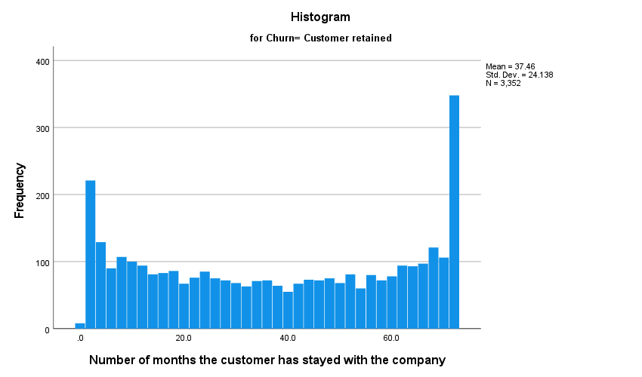

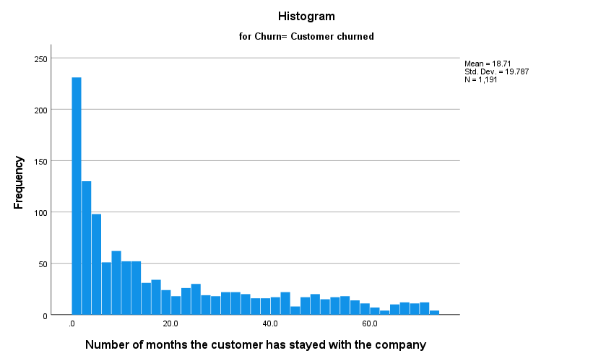

Normal Q-Q Plots

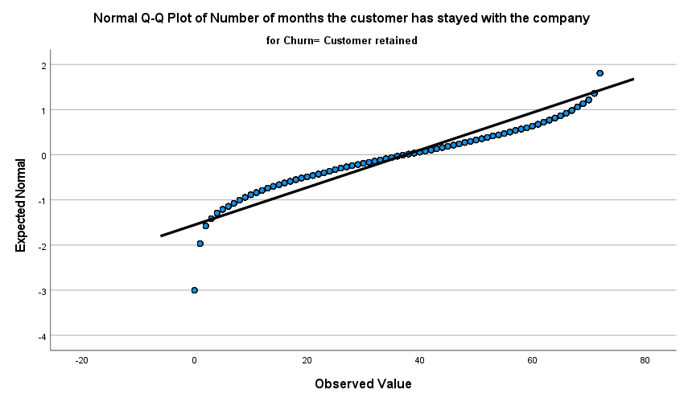

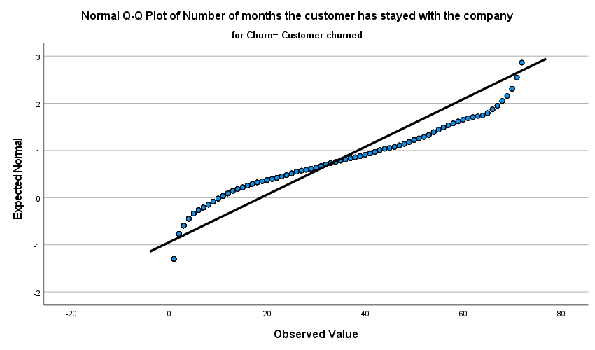

Detrended Normal Q-Q Plots

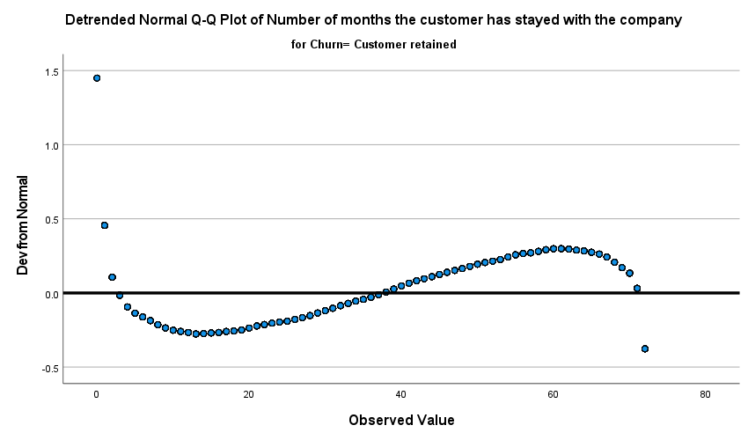

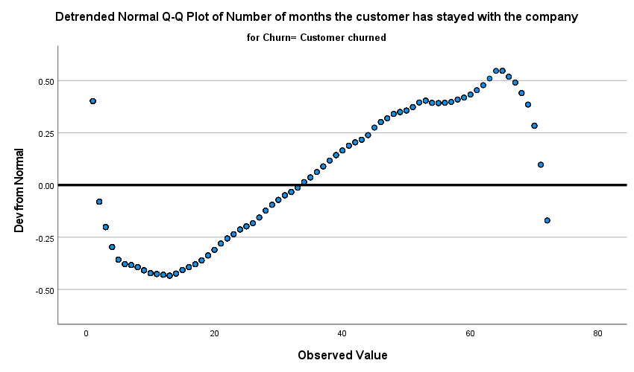

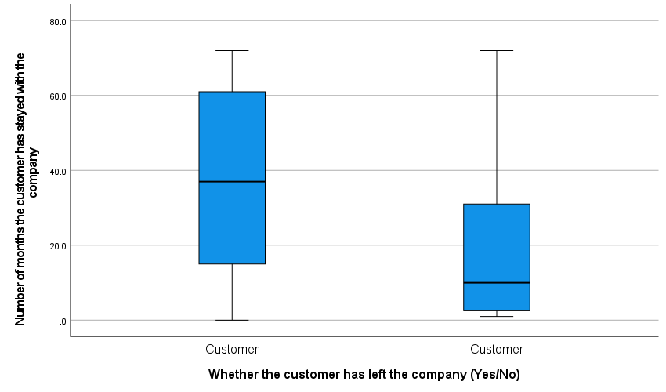

* Data deviates from normality, moving to non-parametric tests

RECODE Churn ('No'=0) ('Yes'=1) INTO Churn_recoded.
VALUE LABELS Churn_recoded
0 'No'
1 'Yes'.
EXECUTE.

NPAR TESTS
/M-W= tenure BY Churn_recoded(0 1)
/STATISTICS=DESCRIPTIVES QUARTILES
/MISSING ANALYSIS.

NPar Tests

Descriptive Statistics
 | N | Mean | Std. Deviation | Minimum | Maximum | Percentiles
 |  |  |  |  |  | 25th | 50th (Median) | 75th
Number of months the customer has stayed with the company | 4543 | 32.547 | 24.5055 | .0 | 72.0 | 9.000 | 29.000 | 56.000
Churn_recoded | 7043 | .2654 | .44156 | .00 | 1.00 | .0000 | .0000 | 1.0000

Mann-Whitney Test

Ranks
 | Churn_recoded | N | Mean Rank | Sum of Ranks
Number of months the customer has stayed with the company | No | 3352 | 2546.27 | 8535101.00
Number of months the customer has stayed with the company | Yes | 1191 | 1500.08 | 1786595.00
Number of months the customer has stayed with the company | Total | 4543

Test Statisticsª
 | Number of months the customer has stayed with the company
Mann-Whitney U | 1076759.000
Wilcoxon W | 1786595.000
Z | -23.656
Asymp. Sig. (2-tailed) | .000
a. Grouping Variable: Churn_recoded

* /RQ-2: Are contract type and customer churn associated?/

DATASET ACTIVATE DataSet1.
CROSSTABS
/TABLES= Churn BY Contract
/FORMAT=AVALUE TABLES
/STATISTICS=CHISQ PHI
/CELLS=COUNT COLUMN
/COUNT ROUND CELL
/BARCHART.

Crosstabs

Case Processing Summary
 | Cases
 | Valid |  | Missing |  | Total
 | N | Percent | N | Percent | N | Percent
Whether the customer has left the company (Yes/No) * Type of contract: Month-to-month, One year, Two year | 7043 | 100.0% | 0 | 0.0% | 7043 | 100.0%

Whether the customer has left the company (Yes/No) * Type of contract: Month-to-month, One year, Two year Crosstabulation
 |  | Type of contract: Month-to-month, One year, Two year |  |  |  |  |  | Total
 |  | Month-to-month |  | One year |  | Two year
 |  | N | % | N | % | N | % | N | %
Whether the customer has left the company (Yes/No) | Customer retained | 2220 | 57.3% | 1307 | 88.7% | 1647 | 97.2% | 5174 | 73.5%
Whether the customer has left the company (Yes/No) | Customer churned | 1655 | 42.7% | 166 | 11.3% | 48 | 2.8% | 1869 | 26.5%
Total |  | 3875 | 100.0% | 1473 | 100.0% | 1695 | 100.0% | 7043 | 100.0%

Chi-Square Tests
 | Value | df | Asymptotic Significance (2-sided)
Pearson Chi-Square | 1184.597ª | 2 | .000
Likelihood Ratio | 1386.810 | 2 | .000
N of Valid Cases | 7043
a. 0 cells (0.0%) have expected count less than 5. The minimum expected count is 390.89.

Symmetric Measures
 |  | Value | Approximate Significance
Nominal by Nominal | Phi | .410 | .000
Nominal by Nominal | Cramer's V | .410 | .000
N of Valid Cases |  | 7043

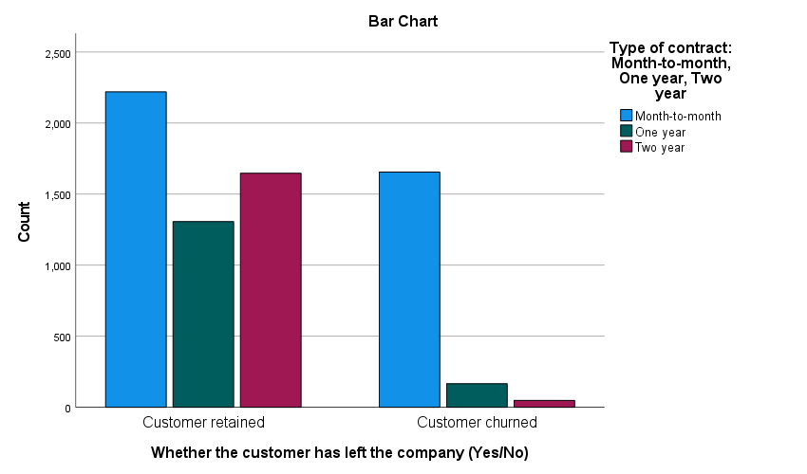

OUTPUT MODIFY
/SELECT TABLES
/IF COMMANDS=["Crosstabs(LAST)"] SUBTYPES=["Crosstabulation"]
/TABLE PIVOT=[R1,C1].
OUTPUT MODIFY
/SELECT TABLES
/IF COMMANDS=["Crosstabs(LAST)"] SUBTYPES=["Crosstabulation"]
/TABLECELLS SELECT=[PERCENT] APPLYTO=COLUMNHEADER REPLACE="%"
/TABLECELLS SELECT=[COUNT] APPLYTO=COLUMNHEADER REPLACE="N".

* /RQ-3: Which customer characteristics are associated with the odds of customer churn?/

LOGISTIC REGRESSION VARIABLES Churn_recoded
/METHOD=ENTER tenure MonthlyCharges Contract TechSupport InternetService PaymentMethod
/CONTRAST (InternetService)=Indicator
/CONTRAST (TechSupport)=Indicator(1)
/CONTRAST (Contract)=Indicator(1)
/CONTRAST (PaymentMethod)=Indicator(1)
/PRINT=GOODFIT CI(95)
/CRITERIA=PIN(0.05) POUT(0.10) ITERATE(20) CUT(0.5).

Logistic Regression

Warnings
Text: Contract Command: LOGISTIC REGRESSION
This procedure cannot use string variables longer than 8 bytes. The values will be truncated.
Text: TechSupport Command: LOGISTIC REGRESSION
This procedure cannot use string variables longer than 8 bytes. The values will be truncated.
Text: InternetService Command: LOGISTIC REGRESSION
This procedure cannot use string variables longer than 8 bytes. The values will be truncated.
Text: PaymentMethod Command: LOGISTIC REGRESSION
This procedure cannot use string variables longer than 8 bytes. The values will be truncated.
Due to redundancies, degrees of freedom have been reduced for one or more variables.

Case Processing Summary
Unweighted Casesª |  | N | Percent
Selected Cases | Included in Analysis | 4543 | 64.5
Selected Cases | Missing Cases | 2500 | 35.5
Selected Cases | Total | 7043 | 100.0
Unselected Cases |  | 0 | .0
Total |  | 7043 | 100.0
a. If weight is in effect, see classification table for the total number of cases.

Dependent Variable Encoding
Original Value | Internal Value
No | 0
Yes | 1

Categorical Variables Codings
 |  | Frequency | Parameter coding
 |  | Frequency | (1) | (2) | (3)
Payment method (e.g., Electronic check, Mailed check, etc.) | Bank tra | 1012 | .000 | .000 | .000
Payment method (e.g., Electronic check, Mailed check, etc.) | Credit c | 976 | 1.000 | .000 | .000
Payment method (e.g., Electronic check, Mailed check, etc.) | Electron | 1529 | .000 | 1.000 | .000
Payment method (e.g., Electronic check, Mailed check, etc.) | Mailed c | 1026 | .000 | .000 | 1.000
Whether the customer has tech support | No | 2225 | .000 | .000
Whether the customer has tech support | No inter | 1008 | 1.000 | .000
Whether the customer has tech support | Yes | 1310 | .000 | 1.000
Customer's internet service provider (DSL, Fiber optic, No) | DSL | 1559 | 1.000 | .000
Customer's internet service provider (DSL, Fiber optic, No) | Fiber op | 1976 | .000 | 1.000
Customer's internet service provider (DSL, Fiber optic, No) | No | 1008 | .000 | .000
Type of contract: Month-to-month, One year, Two year | Month-to | 2462 | .000 | .000
Type of contract: Month-to-month, One year, Two year | One year | 981 | 1.000 | .000
Type of contract: Month-to-month, One year, Two year | Two year | 1100 | .000 | 1.000

Block 0: Beginning Block

Classification Table^{a,b}
 | Observed |  | Predicted
 |  |  | Churn_recoded |  | Percentage Correct
 |  |  | No | Yes | Percentage Correct
Step 0 | Churn_recoded | No | 3352 | 0 | 100.0
Step 0 | Churn_recoded | Yes | 1191 | 0 | .0
Step 0 | Overall Percentage |  |  |  | 73.8
a. Constant is included in the model.
b. The cut value is .500

Variables in the Equation
 |  | B | S.E. | Wald | df | Sig. | Exp(B)
Step 0 | Constant | -1.035 | .034 | 940.926 | 1 | .000 | .355

Variables not in the Equationª
 |  |  | Score | df | Sig.
Step 0 | Variables | Number of months the customer has stayed with the company | 515.074 | 1 | .000
Step 0 | Variables | Monthly charges | 164.711 | 1 | .000
Step 0 | Variables | Type of contract: Month-to-month, One year, Two year | 743.627 | 2 | .000
Step 0 | Variables | Type of contract: Month-to-month, One year, Two year(1) | 130.199 | 1 | .000
Step 0 | Variables | Type of contract: Month-to-month, One year, Two year(2) | 410.795 | 1 | .000
Step 0 | Variables | Whether the customer has tech support | 495.909 | 2 | .000
Step 0 | Variables | Whether the customer has tech support(1) | 228.663 | 1 | .000
Step 0 | Variables | Whether the customer has tech support(2) | 104.739 | 1 | .000
Step 0 | Variables | Customer's internet service provider (DSL, Fiber optic, No) | 451.596 | 2 | .000
Step 0 | Variables | Customer's internet service provider (DSL, Fiber optic, No)(1) | 63.001 | 1 | .000
Step 0 | Variables | Customer's internet service provider (DSL, Fiber optic, No)(2) | 411.094 | 1 | .000
Step 0 | Variables | Payment method (e.g., Electronic check, Mailed check, etc.) | 386.008 | 3 | .000
Step 0 | Variables | Payment method (e.g., Electronic check, Mailed check, etc.)(1) | 77.049 | 1 | .000
Step 0 | Variables | Payment method (e.g., Electronic check, Mailed check, etc.)(2) | 383.049 | 1 | .000
Step 0 | Variables | Payment method (e.g., Electronic check, Mailed check, etc.)(3) | 39.576 | 1 | .000
a. Residual Chi-Squares are not computed because of redundancies.

Block 1: Method = Enter

Omnibus Tests of Model Coefficients
 |  | Chi-square | df | Sig.
Step 1 | Step | 1312.971 | 10 | .000
Step 1 | Block | 1312.971 | 10 | .000
Step 1 | Model | 1312.971 | 10 | .000

Model Summary
Step | -2 Log likelihood | Cox & Snell R Square | Nagelkerke R Square
1 | 3914.257ª | .251 | .367
a. Estimation terminated at iteration number 6 because parameter estimates changed by less than .001.

Hosmer and Lemeshow Test
Step | Chi-square | df | Sig.
1 | 5.454 | 8 | .708

Contingency Table for Hosmer and Lemeshow Test
 |  | Churn_recoded = No |  | Churn_recoded = Yes |  | Total
 |  | Observed | Expected | Observed | Expected | Total
Step 1 | 1 | 451 | 448.893 | 3 | 5.107 | 454
Step 1 | 2 | 442 | 441.890 | 12 | 12.110 | 454
Step 1 | 3 | 429 | 430.532 | 25 | 23.468 | 454
Step 1 | 4 | 408 | 409.332 | 46 | 44.668 | 454
Step 1 | 5 | 367 | 379.402 | 86 | 73.598 | 453
Step 1 | 6 | 353 | 347.932 | 101 | 106.068 | 454
Step 1 | 7 | 311 | 301.756 | 143 | 152.244 | 454
Step 1 | 8 | 251 | 253.778 | 203 | 200.222 | 454
Step 1 | 9 | 204 | 197.205 | 250 | 256.795 | 454
Step 1 | 10 | 136 | 141.282 | 322 | 316.718 | 458

Classification Tableª
 | Observed |  | Predicted
 |  |  | Churn_recoded |  | Percentage Correct
 |  |  | No | Yes | Percentage Correct
Step 1 | Churn_recoded | No | 3018 | 334 | 90.0
Step 1 | Churn_recoded | Yes | 625 | 566 | 47.5
Step 1 | Overall Percentage |  |  |  | 78.9
a. The cut value is .500

Variables in the Equation
 |  | B | S.E. | Wald | df | Sig. | Exp(B) | 95% C.I.for EXP(B)
 |  |  |  |  |  |  |  | Lower | Upper
Step 1ª | Number of months the customer has stayed with the company | -.028 | .003 | 116.915 | 1 | .000 | .973 | .968 | .977
Step 1ª | Monthly charges | .006 | .004 | 2.688 | 1 | .101 | 1.006 | .999 | 1.014
Step 1ª | Type of contract: Month-to-month, One year, Two year |  |  | 78.102 | 2 | .000
Step 1ª | Type of contract: Month-to-month, One year, Two year(1) | -.777 | .126 | 38.312 | 1 | .000 | .460 | .359 | .588
Step 1ª | Type of contract: Month-to-month, One year, Two year(2) | -1.674 | .214 | 61.470 | 1 | .000 | .188 | .123 | .285
Step 1ª | Whether the customer has tech support |  |  | 44.171 | 2 | .000
Step 1ª | Whether the customer has tech support(1) | -1.553 | .290 | 28.664 | 1 | .000 | .212 | .120 | .374
Step 1ª | Whether the customer has tech support(2) | -.307 | .108 | 8.059 | 1 | .005 | .736 | .595 | .909
Step 1ª | Customer's internet service provider (DSL, Fiber optic, No) |  |  | 21.540 | 1 | .000
Step 1ª | Customer's internet service provider (DSL, Fiber optic, No)(1) | -.769 | .166 | 21.540 | 1 | .000 | .464 | .335 | .641
Step 1ª | Payment method (e.g., Electronic check, Mailed check, etc.) |  |  | 28.512 | 3 | .000
Step 1ª | Payment method (e.g., Electronic check, Mailed check, etc.)(1) | -.051 | .138 | .138 | 1 | .710 | .950 | .726 | 1.244
Step 1ª | Payment method (e.g., Electronic check, Mailed check, etc.)(2) | .394 | .113 | 12.234 | 1 | .000 | 1.483 | 1.189 | 1.850
Step 1ª | Payment method (e.g., Electronic check, Mailed check, etc.)(3) | -.096 | .137 | .487 | 1 | .485 | .909 | .695 | 1.189
Step 1ª | Constant | .064 | .340 | .035 | 1 | .852 | 1.066
a. Variable(s) entered on step 1: Number of months the customer has stayed with the company, Monthly charges, Type of contract: Month-to-month, One year, Two year, Whether the customer has tech support, Customer's internet service provider (DSL, Fiber optic, No), Payment method (e.g., Electronic check, Mailed check, etc.).

* Due to redundancies (in predictor variables), degrees of freedom have been reduced for one or more variables (from 11 df to 10 df).
* Now we'll test two reduced models to see which one is more usable.

* Model-1 (Uses InternetService):

LOGISTIC REGRESSION VARIABLES Churn_recoded
/METHOD=ENTER tenure MonthlyCharges PaymentMethod Contract InternetService
/CONTRAST (Contract)=Indicator(1)
/CONTRAST (InternetService)=Indicator
/CONTRAST (PaymentMethod)=Indicator(1)
/PRINT=GOODFIT CI(95)
/CRITERIA=PIN(0.05) POUT(0.10) ITERATE(20) CUT(0.5).

Logistic Regression

Warnings
Text: PaymentMethod Command: LOGISTIC REGRESSION
This procedure cannot use string variables longer than 8 bytes. The values will be truncated.
Text: Contract Command: LOGISTIC REGRESSION
This procedure cannot use string variables longer than 8 bytes. The values will be truncated.
Text: InternetService Command: LOGISTIC REGRESSION
This procedure cannot use string variables longer than 8 bytes. The values will be truncated.

Case Processing Summary
Unweighted Casesª |  | N | Percent
Selected Cases | Included in Analysis | 4543 | 64.5
Selected Cases | Missing Cases | 2500 | 35.5
Selected Cases | Total | 7043 | 100.0
Unselected Cases |  | 0 | .0
Total |  | 7043 | 100.0
a. If weight is in effect, see classification table for the total number of cases.

Dependent Variable Encoding
Original Value | Internal Value
No | 0
Yes | 1

Categorical Variables Codings
 |  | Frequency | Parameter coding
 |  | Frequency | (1) | (2) | (3)
Payment method (e.g., Electronic check, Mailed check, etc.) | Bank tra | 1012 | .000 | .000 | .000
Payment method (e.g., Electronic check, Mailed check, etc.) | Credit c | 976 | 1.000 | .000 | .000
Payment method (e.g., Electronic check, Mailed check, etc.) | Electron | 1529 | .000 | 1.000 | .000
Payment method (e.g., Electronic check, Mailed check, etc.) | Mailed c | 1026 | .000 | .000 | 1.000
Customer's internet service provider (DSL, Fiber optic, No) | DSL | 1559 | 1.000 | .000
Customer's internet service provider (DSL, Fiber optic, No) | Fiber op | 1976 | .000 | 1.000
Customer's internet service provider (DSL, Fiber optic, No) | No | 1008 | .000 | .000
Type of contract: Month-to-month, One year, Two year | Month-to | 2462 | .000 | .000
Type of contract: Month-to-month, One year, Two year | One year | 981 | 1.000 | .000
Type of contract: Month-to-month, One year, Two year | Two year | 1100 | .000 | 1.000

Block 0: Beginning Block

Classification Table^{a,b}
 | Observed |  | Predicted
 |  |  | Churn_recoded |  | Percentage Correct
 |  |  | No | Yes | Percentage Correct
Step 0 | Churn_recoded | No | 3352 | 0 | 100.0
Step 0 | Churn_recoded | Yes | 1191 | 0 | .0
Step 0 | Overall Percentage |  |  |  | 73.8
a. Constant is included in the model.
b. The cut value is .500

Variables in the Equation
 |  | B | S.E. | Wald | df | Sig. | Exp(B)
Step 0 | Constant | -1.035 | .034 | 940.926 | 1 | .000 | .355

Variables not in the Equation
 |  |  | Score | df | Sig.
Step 0 | Variables | Number of months the customer has stayed with the company | 515.074 | 1 | .000
Step 0 | Variables | Monthly charges | 164.711 | 1 | .000
Step 0 | Variables | Payment method (e.g., Electronic check, Mailed check, etc.) | 386.008 | 3 | .000
Step 0 | Variables | Payment method (e.g., Electronic check, Mailed check, etc.)(1) | 77.049 | 1 | .000
Step 0 | Variables | Payment method (e.g., Electronic check, Mailed check, etc.)(2) | 383.049 | 1 | .000
Step 0 | Variables | Payment method (e.g., Electronic check, Mailed check, etc.)(3) | 39.576 | 1 | .000
Step 0 | Variables | Type of contract: Month-to-month, One year, Two year | 743.627 | 2 | .000
Step 0 | Variables | Type of contract: Month-to-month, One year, Two year(1) | 130.199 | 1 | .000
Step 0 | Variables | Type of contract: Month-to-month, One year, Two year(2) | 410.795 | 1 | .000
Step 0 | Variables | Customer's internet service provider (DSL, Fiber optic, No) | 451.596 | 2 | .000
Step 0 | Variables | Customer's internet service provider (DSL, Fiber optic, No)(1) | 63.001 | 1 | .000
Step 0 | Variables | Customer's internet service provider (DSL, Fiber optic, No)(2) | 411.094 | 1 | .000
Step 0 | Overall Statistics |  | 1121.635 | 9 | .000

Block 1: Method = Enter

Omnibus Tests of Model Coefficients
 |  | Chi-square | df | Sig.
Step 1 | Step | 1304.851 | 9 | .000
Step 1 | Block | 1304.851 | 9 | .000
Step 1 | Model | 1304.851 | 9 | .000

Model Summary
Step | -2 Log likelihood | Cox & Snell R Square | Nagelkerke R Square
1 | 3922.377ª | .250 | .365
a. Estimation terminated at iteration number 6 because parameter estimates changed by less than .001.

Hosmer and Lemeshow Test
Step | Chi-square | df | Sig.
1 | 17.656 | 8 | .024

Contingency Table for Hosmer and Lemeshow Test
 |  | Churn_recoded = No |  | Churn_recoded = Yes |  | Total
 |  | Observed | Expected | Observed | Expected | Total
Step 1 | 1 | 450 | 448.981 | 4 | 5.019 | 454
Step 1 | 2 | 446 | 441.919 | 8 | 12.081 | 454
Step 1 | 3 | 424 | 430.365 | 30 | 23.635 | 454
Step 1 | 4 | 411 | 408.705 | 43 | 45.295 | 454
Step 1 | 5 | 358 | 381.523 | 98 | 74.477 | 456
Step 1 | 6 | 366 | 346.556 | 88 | 107.444 | 454
Step 1 | 7 | 307 | 302.020 | 147 | 151.980 | 454
Step 1 | 8 | 250 | 253.915 | 204 | 200.085 | 454
Step 1 | 9 | 201 | 196.698 | 253 | 257.302 | 454
Step 1 | 10 | 139 | 141.319 | 316 | 313.681 | 455

Classification Tableª
 | Observed |  | Predicted
 |  |  | Churn_recoded |  | Percentage Correct
 |  |  | No | Yes | Percentage Correct
Step 1 | Churn_recoded | No | 3023 | 329 | 90.2
Step 1 | Churn_recoded | Yes | 626 | 565 | 47.4
Step 1 | Overall Percentage |  |  |  | 79.0
a. The cut value is .500

Variables in the Equation
 |  | B | S.E. | Wald | df | Sig. | Exp(B) | 95% C.I.for EXP(B)
 |  |  |  |  |  |  |  | Lower | Upper
Step 1ª | Number of months the customer has stayed with the company | -.028 | .003 | 117.511 | 1 | .000 | .973 | .968 | .977
Step 1ª | Monthly charges | .003 | .004 | .634 | 1 | .426 | 1.003 | .996 | 1.010
Step 1ª | Payment method (e.g., Electronic check, Mailed check, etc.) |  |  | 31.203 | 3 | .000
Step 1ª | Payment method (e.g., Electronic check, Mailed check, etc.)(1) | -.056 | .137 | .169 | 1 | .681 | .945 | .722 | 1.237
Step 1ª | Payment method (e.g., Electronic check, Mailed check, etc.)(2) | .406 | .112 | 13.047 | 1 | .000 | 1.501 | 1.204 | 1.871
Step 1ª | Payment method (e.g., Electronic check, Mailed check, etc.)(3) | -.108 | .137 | .621 | 1 | .431 | .898 | .687 | 1.174
Step 1ª | Type of contract: Month-to-month, One year, Two year |  |  | 87.098 | 2 | .000
Step 1ª | Type of contract: Month-to-month, One year, Two year(1) | -.812 | .125 | 42.227 | 1 | .000 | .444 | .348 | .567
Step 1ª | Type of contract: Month-to-month, One year, Two year(2) | -1.752 | .212 | 68.363 | 1 | .000 | .173 | .115 | .263
Step 1ª | Customer's internet service provider (DSL, Fiber optic, No) |  |  | 39.482 | 2 | .000
Step 1ª | Customer's internet service provider (DSL, Fiber optic, No)(1) | .790 | .186 | 18.113 | 1 | .000 | 2.204 | 1.532 | 3.171
Step 1ª | Customer's internet service provider (DSL, Fiber optic, No)(2) | 1.710 | .284 | 36.339 | 1 | .000 | 5.528 | 3.170 | 9.637
Step 1ª | Constant | -1.399 | .175 | 63.620 | 1 | .000 | .247
a. Variable(s) entered on step 1: Number of months the customer has stayed with the company, Monthly charges, Payment method (e.g., Electronic check, Mailed check, etc.), Type of contract: Month-to-month, One year, Two year, Customer's internet service provider (DSL, Fiber optic, No).

* H-L test is significant, thus this model is rejected.

* Model-2 (Uses TechSupport):

LOGISTIC REGRESSION VARIABLES Churn_recoded
/METHOD=ENTER tenure MonthlyCharges PaymentMethod Contract TechSupport
/CONTRAST (Contract)=Indicator(1)
/CONTRAST (TechSupport)=Indicator(1)
/CONTRAST (PaymentMethod)=Indicator(1)
/PRINT=GOODFIT CI(95)
/CRITERIA=PIN(0.05) POUT(0.10) ITERATE(20) CUT(0.5).

Logistic Regression

Warnings
Text: PaymentMethod Command: LOGISTIC REGRESSION
This procedure cannot use string variables longer than 8 bytes. The values will be truncated.
Text: Contract Command: LOGISTIC REGRESSION
This procedure cannot use string variables longer than 8 bytes. The values will be truncated.
Text: TechSupport Command: LOGISTIC REGRESSION
This procedure cannot use string variables longer than 8 bytes. The values will be truncated.

Case Processing Summary
Unweighted Casesª |  | N | Percent
Selected Cases | Included in Analysis | 4543 | 64.5
Selected Cases | Missing Cases | 2500 | 35.5
Selected Cases | Total | 7043 | 100.0
Unselected Cases |  | 0 | .0
Total |  | 7043 | 100.0
a. If weight is in effect, see classification table for the total number of cases.

Dependent Variable Encoding
Original Value | Internal Value
No | 0
Yes | 1

Categorical Variables Codings
 |  | Frequency | Parameter coding
 |  | Frequency | (1) | (2) | (3)
Payment method (e.g., Electronic check, Mailed check, etc.) | Bank tra | 1012 | .000 | .000 | .000
Payment method (e.g., Electronic check, Mailed check, etc.) | Credit c | 976 | 1.000 | .000 | .000
Payment method (e.g., Electronic check, Mailed check, etc.) | Electron | 1529 | .000 | 1.000 | .000
Payment method (e.g., Electronic check, Mailed check, etc.) | Mailed c | 1026 | .000 | .000 | 1.000
Whether the customer has tech support | No | 2225 | .000 | .000
Whether the customer has tech support | No inter | 1008 | 1.000 | .000
Whether the customer has tech support | Yes | 1310 | .000 | 1.000
Type of contract: Month-to-month, One year, Two year | Month-to | 2462 | .000 | .000
Type of contract: Month-to-month, One year, Two year | One year | 981 | 1.000 | .000
Type of contract: Month-to-month, One year, Two year | Two year | 1100 | .000 | 1.000

Block 0: Beginning Block

Classification Table^{a,b}
 | Observed |  | Predicted
 |  |  | Churn_recoded |  | Percentage Correct
 |  |  | No | Yes | Percentage Correct
Step 0 | Churn_recoded | No | 3352 | 0 | 100.0
Step 0 | Churn_recoded | Yes | 1191 | 0 | .0
Step 0 | Overall Percentage |  |  |  | 73.8
a. Constant is included in the model.
b. The cut value is .500

Variables in the Equation
 |  | B | S.E. | Wald | df | Sig. | Exp(B)
Step 0 | Constant | -1.035 | .034 | 940.926 | 1 | .000 | .355

Variables not in the Equation
 |  |  | Score | df | Sig.
Step 0 | Variables | Number of months the customer has stayed with the company | 515.074 | 1 | .000
Step 0 | Variables | Monthly charges | 164.711 | 1 | .000
Step 0 | Variables | Payment method (e.g., Electronic check, Mailed check, etc.) | 386.008 | 3 | .000
Step 0 | Variables | Payment method (e.g., Electronic check, Mailed check, etc.)(1) | 77.049 | 1 | .000
Step 0 | Variables | Payment method (e.g., Electronic check, Mailed check, etc.)(2) | 383.049 | 1 | .000
Step 0 | Variables | Payment method (e.g., Electronic check, Mailed check, etc.)(3) | 39.576 | 1 | .000
Step 0 | Variables | Type of contract: Month-to-month, One year, Two year | 743.627 | 2 | .000
Step 0 | Variables | Type of contract: Month-to-month, One year, Two year(1) | 130.199 | 1 | .000
Step 0 | Variables | Type of contract: Month-to-month, One year, Two year(2) | 410.795 | 1 | .000
Step 0 | Variables | Whether the customer has tech support | 495.909 | 2 | .000
Step 0 | Variables | Whether the customer has tech support(1) | 228.663 | 1 | .000
Step 0 | Variables | Whether the customer has tech support(2) | 104.739 | 1 | .000
Step 0 | Overall Statistics |  | 1098.374 | 9 | .000

Block 1: Method = Enter

Omnibus Tests of Model Coefficients
 |  | Chi-square | df | Sig.
Step 1 | Step | 1291.125 | 9 | .000
Step 1 | Block | 1291.125 | 9 | .000
Step 1 | Model | 1291.125 | 9 | .000

Model Summary
Step | -2 Log likelihood | Cox & Snell R Square | Nagelkerke R Square
1 | 3936.103ª | .247 | .362
a. Estimation terminated at iteration number 6 because parameter estimates changed by less than .001.

Hosmer and Lemeshow Test
Step | Chi-square | df | Sig.
1 | 11.632 | 8 | .168

Contingency Table for Hosmer and Lemeshow Test
 |  | Churn_recoded = No |  | Churn_recoded = Yes |  | Total
 |  | Observed | Expected | Observed | Expected | Total
Step 1 | 1 | 449 | 449.191 | 5 | 4.809 | 454
Step 1 | 2 | 445 | 441.749 | 9 | 12.251 | 454
Step 1 | 3 | 429 | 431.198 | 25 | 22.802 | 454
Step 1 | 4 | 404 | 408.933 | 50 | 45.067 | 454
Step 1 | 5 | 370 | 378.659 | 84 | 75.341 | 454
Step 1 | 6 | 346 | 346.498 | 108 | 107.502 | 454
Step 1 | 7 | 303 | 297.167 | 151 | 156.833 | 454
Step 1 | 8 | 277 | 250.277 | 177 | 203.723 | 454
Step 1 | 9 | 195 | 201.492 | 259 | 252.508 | 454
Step 1 | 10 | 134 | 146.835 | 323 | 310.165 | 457

Classification Tableª
 | Observed |  | Predicted
 |  |  | Churn_recoded |  | Percentage Correct
 |  |  | No | Yes | Percentage Correct
Step 1 | Churn_recoded | No | 3004 | 348 | 89.6
Step 1 | Churn_recoded | Yes | 597 | 594 | 49.9
Step 1 | Overall Percentage |  |  |  | 79.2
a. The cut value is .500

Variables in the Equation
 |  | B | S.E. | Wald | df | Sig. | Exp(B) | 95% C.I.for EXP(B)
 |  |  |  |  |  |  |  | Lower | Upper
Step 1ª | Number of months the customer has stayed with the company | -.029 | .003 | 133.258 | 1 | .000 | .971 | .966 | .976
Step 1ª | Monthly charges | .022 | .002 | 95.177 | 1 | .000 | 1.022 | 1.017 | 1.026
Step 1ª | Payment method (e.g., Electronic check, Mailed check, etc.) |  |  | 32.633 | 3 | .000
Step 1ª | Payment method (e.g., Electronic check, Mailed check, etc.)(1) | -.049 | .137 | .127 | 1 | .721 | .952 | .728 | 1.246
Step 1ª | Payment method (e.g., Electronic check, Mailed check, etc.)(2) | .412 | .112 | 13.483 | 1 | .000 | 1.510 | 1.212 | 1.881
Step 1ª | Payment method (e.g., Electronic check, Mailed check, etc.)(3) | -.120 | .136 | .781 | 1 | .377 | .887 | .679 | 1.158
Step 1ª | Type of contract: Month-to-month, One year, Two year |  |  | 95.580 | 2 | .000
Step 1ª | Type of contract: Month-to-month, One year, Two year(1) | -.869 | .124 | 49.299 | 1 | .000 | .419 | .329 | .534
Step 1ª | Type of contract: Month-to-month, One year, Two year(2) | -1.797 | .212 | 71.909 | 1 | .000 | .166 | .109 | .251
Step 1ª | Whether the customer has tech support |  |  | 26.076 | 2 | .000
Step 1ª | Whether the customer has tech support(1) | -.466 | .174 | 7.142 | 1 | .008 | .628 | .446 | .883
Step 1ª | Whether the customer has tech support(2) | -.470 | .102 | 21.078 | 1 | .000 | .625 | .511 | .764
Step 1ª | Constant | -1.277 | .184 | 47.933 | 1 | .000 | .279
a. Variable(s) entered on step 1: Number of months the customer has stayed with the company, Monthly charges, Payment method (e.g., Electronic check, Mailed check, etc.), Type of contract: Month-to-month, One year, Two year, Whether the customer has tech support.

* H-L test isn't significant, thus this model is accepted as final model.

* /Task-3: Graphs/

* /G-1/

* Chart Builder.
GGRAPH
/GRAPHDATASET NAME="graphdataset" VARIABLES=Churn COUNT()[name="COUNT"] MISSING=LISTWISE
REPORTMISSING=NO
/GRAPHSPEC SOURCE=INLINE
/FRAME OUTER=NO INNER=NO
/GRIDLINES XAXIS=NO YAXIS=YES
/STYLE GRADIENT=NO.
BEGIN GPL
SOURCE: s=userSource(id("graphdataset"))
DATA: Churn=col(source(s), name("Churn"), unit.category())
DATA: COUNT=col(source(s), name("COUNT"))
GUIDE: axis(dim(1), label("Whether the customer has left the company (Yes/No)"))
GUIDE: axis(dim(2), label("Percent"))
GUIDE: text.title(label("Churn status percentage bar chart"))
SCALE: cat(dim(1), include("No", "Yes"))
SCALE: linear(dim(2), include(0))
ELEMENT: interval(position(summary.percent(Churn*COUNT, base.all(acrossPanels()))),
shape.interior(shape.square))
END GPL.

GGraph

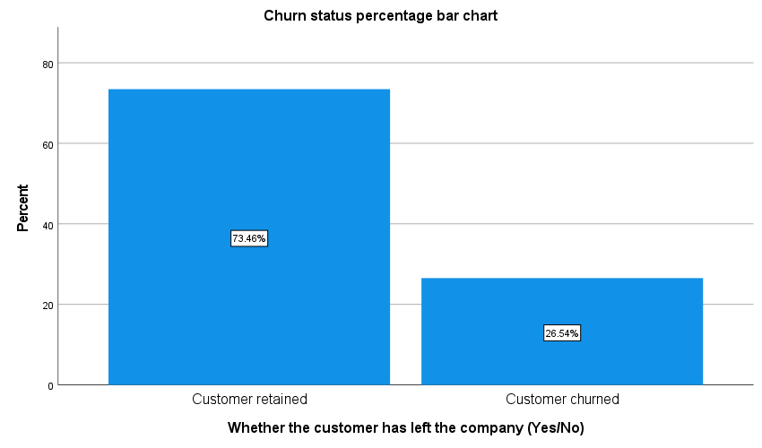

* /G-2/

* Chart Builder.
GGRAPH
/GRAPHDATASET NAME="graphdataset" VARIABLES=tenure Churn MISSING=LISTWISE REPORTMISSING=NO
/GRAPHSPEC SOURCE=INLINE
/COLORCYCLE COLOR1(95,195,56), COLOR2(215,0,51), COLOR3(159,24,83), COLOR4(250,77,86),
COLOR5(87,4,8), COLOR6(25,128,56), COLOR7(0,45,156), COLOR8(238,83,139), COLOR9(178,134,0),
COLOR10(0,157,154), COLOR11(1,39,73), COLOR12(138,56,0), COLOR13(165,110,255),
COLOR14(236,230,208), COLOR15(69,70,71), COLOR16(92,202,136), COLOR17(208,83,52),
COLOR18(204,127,228), COLOR19(225,188,29), COLOR20(237,75,75), COLOR21(28,205,205),
COLOR22(92,113,72), COLOR23(225,139,14), COLOR24(9,38,114), COLOR25(90,100,94), COLOR26(155,0,0),
COLOR27(207,172,227), COLOR28(150,145,145), COLOR29(63,235,124), COLOR30(105,41,196)
/FRAME OUTER=NO INNER=NO
/GRIDLINES XAXIS=NO YAXIS=YES
/STYLE GRADIENT=NO.
BEGIN GPL
SOURCE: s=userSource(id("graphdataset"))
DATA: tenure=col(source(s), name("tenure"))
DATA: Churn=col(source(s), name("Churn"), unit.category())
GUIDE: axis(dim(1), label("Number of months the customer has stayed with the company"))
GUIDE: axis(dim(2), label("Frequency Percent"))
GUIDE: legend(aesthetic(aesthetic.color.interior), label("Whether the customer has left the ",
"company (Yes/No)"))
GUIDE: text.title(label("Tenure histogram (Split by churn status)"))
SCALE: cat(aesthetic(aesthetic.color.interior), include(
"No", "Yes"))
ELEMENT: interval.stack(position(summary.percent.count(bin.rect(tenure),
base.all(acrossPanels()))), color.interior(Churn), shape.interior(shape.square))
END GPL.

GGraph

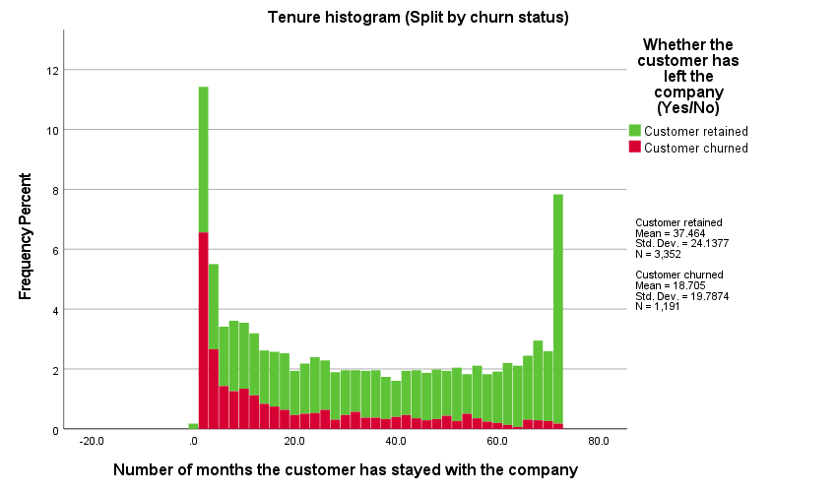

* /G-3/

* Chart Builder.
GGRAPH
/GRAPHDATASET NAME="graphdataset" VARIABLES=Churn tenure MISSING=LISTWISE REPORTMISSING=NO
/GRAPHSPEC SOURCE=INLINE
/FRAME OUTER=NO INNER=NO
/GRIDLINES XAXIS=NO YAXIS=YES
/STYLE GRADIENT=NO.
BEGIN GPL
SOURCE: s=userSource(id("graphdataset"))
DATA: Churn=col(source(s), name("Churn"), unit.category())
DATA: tenure=col(source(s), name("tenure"))
DATA: id=col(source(s), name("$CASENUM"), unit.category())
GUIDE: axis(dim(1), label("Whether the customer has left the company (Yes/No)"))
GUIDE: axis(dim(2), label("Number of months the customer has stayed with the company"))
GUIDE: text.title(label("Tenure by Churn boxplot"))
SCALE: cat(dim(1), include("No", "Yes"))
SCALE: linear(dim(2), include(0))
ELEMENT: schema(position(bin.quantile.letter(Churn*tenure)), label(id))
END GPL.

GGraph

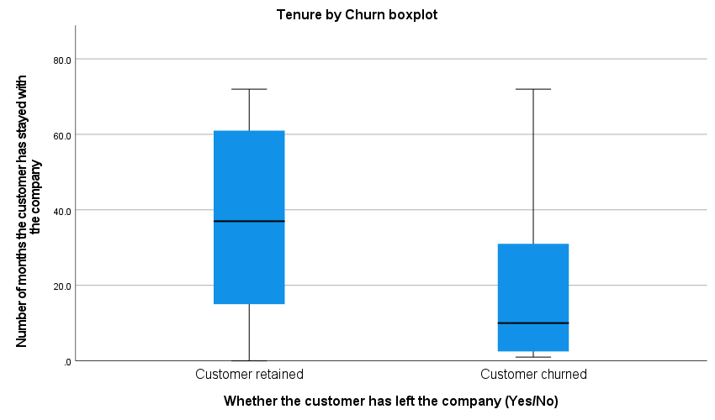

* /G-4/

* Chart Builder.
GGRAPH
/GRAPHDATASET NAME="graphdataset" VARIABLES=Contract COUNT()[name="COUNT"] Churn MISSING=LISTWISE
REPORTMISSING=NO
/GRAPHSPEC SOURCE=INLINE
/COLORCYCLE COLOR1(215,0,51), COLOR2(95,195,56), COLOR3(159,24,83), COLOR4(250,77,86),
COLOR5(87,4,8), COLOR6(25,128,56), COLOR7(0,45,156), COLOR8(238,83,139), COLOR9(178,134,0),
COLOR10(0,157,154), COLOR11(1,39,73), COLOR12(138,56,0), COLOR13(165,110,255),
COLOR14(236,230,208), COLOR15(69,70,71), COLOR16(92,202,136), COLOR17(208,83,52),
COLOR18(204,127,228), COLOR19(225,188,29), COLOR20(237,75,75), COLOR21(28,205,205),
COLOR22(92,113,72), COLOR23(225,139,14), COLOR24(9,38,114), COLOR25(90,100,94), COLOR26(155,0,0),
COLOR27(207,172,227), COLOR28(150,145,145), COLOR29(63,235,124), COLOR30(105,41,196)
/FRAME OUTER=NO INNER=NO
/GRIDLINES XAXIS=NO YAXIS=YES
/STYLE GRADIENT=NO.
BEGIN GPL
SOURCE: s=userSource(id("graphdataset"))
DATA: Contract=col(source(s), name("Contract"), unit.category())
DATA: COUNT=col(source(s), name("COUNT"))
DATA: Churn=col(source(s), name("Churn"), unit.category())
COORD: rect(dim(1,2), transpose())
GUIDE: axis(dim(1), label("Type of contract: Month-to-month, One year, Two year"))
GUIDE: axis(dim(2), label("Percent"))
GUIDE: legend(aesthetic(aesthetic.color.interior), label("Whether the customer has left the ",
"company (Yes/No)"))
GUIDE: text.title(label("Stacked bar chart of contract type by churn status"))
SCALE: cat(dim(1), reverse())
SCALE: linear(dim(2), include(0))
SCALE: cat(aesthetic(aesthetic.color.interior), reverse(), include(
"No", "Yes"))
ELEMENT: interval.stack(position(Contract*COUNT), color.interior(Churn),
shape.interior(shape.square))
END GPL.

GGraph

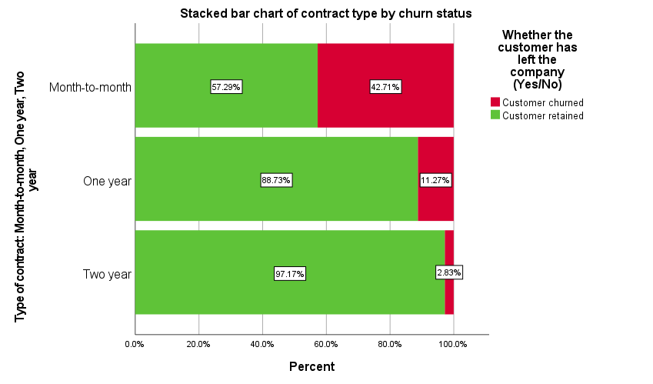

* /G-5/

* Chart Builder.
GGRAPH
/GRAPHDATASET NAME="graphdataset" VARIABLES=PaymentMethod COUNT()[name="COUNT"] Churn
MISSING=LISTWISE REPORTMISSING=NO
/GRAPHSPEC SOURCE=INLINE
/COLORCYCLE COLOR1(215,0,51), COLOR2(95,195,56), COLOR3(159,24,83), COLOR4(250,77,86),
COLOR5(87,4,8), COLOR6(25,128,56), COLOR7(0,45,156), COLOR8(238,83,139), COLOR9(178,134,0),
COLOR10(0,157,154), COLOR11(1,39,73), COLOR12(138,56,0), COLOR13(165,110,255),
COLOR14(236,230,208), COLOR15(69,70,71), COLOR16(92,202,136), COLOR17(208,83,52),
COLOR18(204,127,228), COLOR19(225,188,29), COLOR20(237,75,75), COLOR21(28,205,205),
COLOR22(92,113,72), COLOR23(225,139,14), COLOR24(9,38,114), COLOR25(90,100,94), COLOR26(155,0,0),
COLOR27(207,172,227), COLOR28(150,145,145), COLOR29(63,235,124), COLOR30(105,41,196)
/FRAME OUTER=NO INNER=NO
/GRIDLINES XAXIS=NO YAXIS=YES
/STYLE GRADIENT=NO.
BEGIN GPL
SOURCE: s=userSource(id("graphdataset"))
DATA: PaymentMethod=col(source(s), name("PaymentMethod"), unit.category())
DATA: COUNT=col(source(s), name("COUNT"))
DATA: Churn=col(source(s), name("Churn"), unit.category())
COORD: rect(dim(1,2), transpose())
GUIDE: axis(dim(1), label("Payment method (e.g., Electronic check, Mailed check, etc.)"))
GUIDE: axis(dim(2), label("Percent"))
GUIDE: legend(aesthetic(aesthetic.color.interior), label("Whether the customer has left the ",
"company (Yes/No)"))
GUIDE: text.title(label("Stacked bar chart of payment method by churn status"))
SCALE: cat(dim(1), reverse())
SCALE: linear(dim(2), include(0))
SCALE: cat(aesthetic(aesthetic.color.interior), reverse(), include(
"No", "Yes"))
ELEMENT: interval.stack(position(PaymentMethod*COUNT), color.interior(Churn),
shape.interior(shape.square))
END GPL.

GGraph

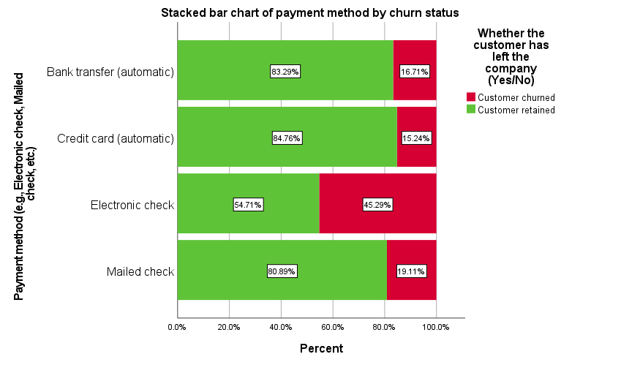

* /G-6/

* Chart Builder.
GGRAPH
/GRAPHDATASET NAME="graphdataset" VARIABLES=InternetService COUNT()[name="COUNT"] Churn
MISSING=LISTWISE REPORTMISSING=NO
/GRAPHSPEC SOURCE=INLINE
/COLORCYCLE COLOR1(215,0,51), COLOR2(95,195,56), COLOR3(159,24,83), COLOR4(250,77,86),
COLOR5(87,4,8), COLOR6(25,128,56), COLOR7(0,45,156), COLOR8(238,83,139), COLOR9(178,134,0),
COLOR10(0,157,154), COLOR11(1,39,73), COLOR12(138,56,0), COLOR13(165,110,255),
COLOR14(236,230,208), COLOR15(69,70,71), COLOR16(92,202,136), COLOR17(208,83,52),
COLOR18(204,127,228), COLOR19(225,188,29), COLOR20(237,75,75), COLOR21(28,205,205),
COLOR22(92,113,72), COLOR23(225,139,14), COLOR24(9,38,114), COLOR25(90,100,94), COLOR26(155,0,0),
COLOR27(207,172,227), COLOR28(150,145,145), COLOR29(63,235,124), COLOR30(105,41,196)
/FRAME OUTER=NO INNER=NO
/GRIDLINES XAXIS=NO YAXIS=YES
/STYLE GRADIENT=NO.
BEGIN GPL
SOURCE: s=userSource(id("graphdataset"))
DATA: InternetService=col(source(s), name("InternetService"), unit.category())
DATA: COUNT=col(source(s), name("COUNT"))
DATA: Churn=col(source(s), name("Churn"), unit.category())
COORD: rect(dim(1,2), transpose())
GUIDE: axis(dim(1), label("Customer's internet service provider (DSL, Fiber optic, No)"))
GUIDE: axis(dim(2), label("Percent"))
GUIDE: legend(aesthetic(aesthetic.color.interior), label("Whether the customer has left the ",
"company (Yes/No)"))
GUIDE: text.title(label("Stacked bar chart of customer's internet service by churn status"))
SCALE: linear(dim(2), include(0))
SCALE: cat(aesthetic(aesthetic.color.interior), reverse(), include(
"No", "Yes"))
ELEMENT: interval.stack(position(InternetService*COUNT), color.interior(Churn),
shape.interior(shape.square))
END GPL.

GGraph

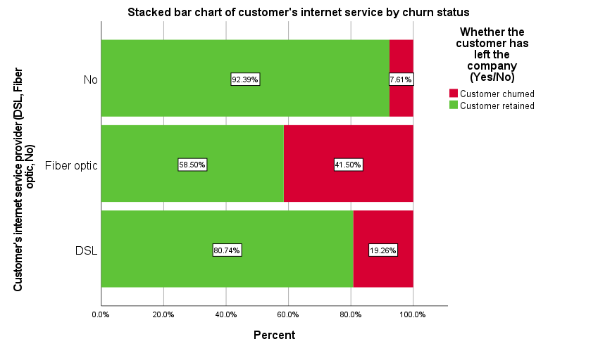

SAVE OUTFILE='E:\Statistical Softwares\SPSS\CUSPC-SPSS\Assignments\Final Project\Final_Project.sav'
/COMPRESSED.
Appendix C
SPSS Syntax
* Encoding: UTF-8.

* /Step-1: Data loading/

PRESERVE.
SET DECIMAL DOT.

GET DATA /TYPE=TXT
/FILE="E:\Statistical Softwares\SPSS\CUSPC-SPSS\Assignments\Final Project\telco_data.csv"
/ENCODING='UTF8'
/DELIMITERS=","
/QUALIFIER='"'
/ARRANGEMENT=DELIMITED
/FIRSTCASE=2
/DATATYPEMIN PERCENTAGE=95.0
/VARIABLES=
customerID AUTO
gender AUTO
SeniorCitizen AUTO
Partner AUTO
Dependents AUTO
tenure AUTO
PhoneService AUTO
MultipleLines AUTO
InternetService AUTO
OnlineSecurity AUTO
OnlineBackup AUTO
DeviceProtection AUTO
TechSupport AUTO
StreamingTV AUTO
StreamingMovies AUTO
Contract AUTO
PaperlessBilling AUTO
PaymentMethod AUTO
MonthlyCharges AUTO
TotalCharges AUTO
Churn AUTO
/MAP.
RESTORE.
CACHE.
EXECUTE.
DATASET NAME DataSet1 WINDOW=FRONT.

SAVE OUTFILE='E:\Statistical Softwares\SPSS\CUSPC-SPSS\Assignments\Final Project\Final_Project.sav'
/COMPRESSED.

* /Step-2: Initial data Checking/

DATASET ACTIVATE DataSet1.
FREQUENCIES VARIABLES=customerID gender SeniorCitizen Partner Dependents tenure PhoneService
MultipleLines InternetService OnlineSecurity OnlineBackup DeviceProtection TechSupport StreamingTV
StreamingMovies Contract PaperlessBilling PaymentMethod MonthlyCharges TotalCharges Churn
/FORMAT=NOTABLE
/STATISTICS=RANGE MINIMUM MAXIMUM
/ORDER=ANALYSIS.

* /Step-3: Fixing "SPSS failing to find missing value properly" issue/

MISSING VALUES gender Partner InternetService StreamingTV (' ').

* Checking again if things are okay or not

DATASET ACTIVATE DataSet1.
FREQUENCIES VARIABLES=customerID gender SeniorCitizen Partner Dependents tenure PhoneService
MultipleLines InternetService OnlineSecurity OnlineBackup DeviceProtection TechSupport StreamingTV
StreamingMovies Contract PaperlessBilling PaymentMethod MonthlyCharges TotalCharges Churn
/FORMAT=NOTABLE
/STATISTICS=RANGE MINIMUM MAXIMUM
/ORDER=ANALYSIS.

* /Step-4: Checking or fixing duplicate observations/

DATASET ACTIVATE DataSet1.
* Identify Duplicate Cases.
SORT CASES BY customerID(A).
MATCH FILES
/FILE=*
/BY customerID
/FIRST=PrimaryFirst
/LAST=PrimaryLast.
DO IF (PrimaryFirst).
COMPUTE MatchSequence=1-PrimaryLast.
ELSE.
COMPUTE MatchSequence=MatchSequence+1.
END IF.
LEAVE MatchSequence.
FORMATS MatchSequence (f7).
COMPUTE InDupGrp=MatchSequence>0.
SORT CASES InDupGrp(D).
MATCH FILES
/FILE=*
/DROP=PrimaryFirst InDupGrp MatchSequence.
VARIABLE LABELS PrimaryLast 'Indicator of each last matching case as Primary'.
VALUE LABELS PrimaryLast 0 'Duplicate Case' 1 'Primary Case'.
VARIABLE LEVEL PrimaryLast (ORDINAL).
FREQUENCIES VARIABLES=PrimaryLast.
EXECUTE.

* No duplicates exist, splendid.

* /Step-4: Data labelling/

VARIABLE LABELS
customerID "Unique identifier for each customer"
gender "Customer gender: Male/Female"
SeniorCitizen "Indicates if the customer is a senior citizen (0 = No, 1 = Yes)"
Partner "Whether the customer has a partner"
Dependents "Whether the customer has dependents"
tenure "Number of months the customer has stayed with the company"
PhoneService "Whether the customer has phone service"
MultipleLines "Whether the customer has multiple lines"
InternetService "Customer's internet service provider (DSL, Fiber optic, No)"
OnlineSecurity "Whether the customer has online security"
OnlineBackup "Whether the customer has online backup"
DeviceProtection "Whether the customer has device protection"
TechSupport "Whether the customer has tech support"
StreamingTV "Whether the customer has streaming TV"
StreamingMovies "Whether the customer has streaming movies"
Contract "Type of contract: Month-to-month, One year, Two year"
PaperlessBilling "Whether the customer uses paperless billing"
PaymentMethod "Payment method (e.g., Electronic check, Mailed check, etc.)"
MonthlyCharges "Monthly charges"
TotalCharges "Total charges to date"
Churn "Whether the customer has left the company (Yes/No)".
EXECUTE.

VALUE LABELS
SeniorCitizen
0 "No"
1 "Yes".

VALUE LABELS
Churn
"No" "Customer retained"
"Yes" "Customer churned".

EXECUTE.

* Things are okay now, we can move onto any required furthur procressing and analysis.

SAVE OUTFILE='E:\Statistical Softwares\SPSS\CUSPC-SPSS\Assignments\Final Project\Final_Project.sav'
/COMPRESSED.

* /Task-1: Table-1/

* Custom Tables.
CTABLES
/VLABELS VARIABLES=gender SeniorCitizen Partner Dependents tenure PhoneService MultipleLines
InternetService OnlineSecurity OnlineBackup DeviceProtection TechSupport StreamingTV
StreamingMovies Contract PaperlessBilling PaymentMethod MonthlyCharges TotalCharges Churn
DISPLAY=LABEL
/TABLE gender [COUNT 'Frequency' F40.0, TABLEPCT.COUNT 'Percentage' PCT40.2] + SeniorCitizen
[COUNT 'Frequency' F40.0, TABLEPCT.COUNT 'Percentage' PCT40.2] + Partner [COUNT 'Frequency' F40.0, TABLEPCT.COUNT 'Percentage' PCT40.2] + Dependents
[COUNT 'Frequency' F40.0, TABLEPCT.COUNT 'Percentage' PCT40.2] + tenure [MEAN, STDDEV, MEDIAN,
MINIMUM, MAXIMUM] + PhoneService [COUNT 'Frequency' F40.0, TABLEPCT.COUNT 'Percentage' PCT40.2] +
MultipleLines [COUNT 'Frequency' F40.0, TABLEPCT.COUNT 'Percentage' PCT40.2] + InternetService
[COUNT 'Frequency' F40.0, TABLEPCT.COUNT 'Percentage' PCT40.2] + OnlineSecurity [COUNT 'Frequency'
F40.0, TABLEPCT.COUNT 'Percentage' PCT40.2] + OnlineBackup [COUNT 'Frequency' F40.0, TABLEPCT.COUNT
'Percentage' PCT40.2] + DeviceProtection [COUNT 'Frequency' F40.0, TABLEPCT.COUNT 'Percentage'
PCT40.2] + TechSupport [COUNT 'Frequency' F40.0, TABLEPCT.COUNT 'Percentage' PCT40.2] + StreamingTV
[COUNT 'Frequency' F40.0, TABLEPCT.COUNT 'Percentage' PCT40.2] + StreamingMovies [COUNT 'Frequency'
F40.0, TABLEPCT.COUNT 'Percentage' PCT40.2] + Contract [COUNT 'Frequency' F40.0, TABLEPCT.COUNT
'Percentage' PCT40.2] + PaperlessBilling [COUNT 'Frequency' F40.0, TABLEPCT.COUNT 'Percentage'
PCT40.2] + PaymentMethod [COUNT 'Frequency' F40.0, TABLEPCT.COUNT 'Percentage' PCT40.2] +
MonthlyCharges [MEAN, STDDEV, MEDIAN, MINIMUM, MAXIMUM] + TotalCharges [MEAN, STDDEV, MEDIAN,
MINIMUM, MAXIMUM] + Churn [COUNT 'Frequency' F40.0, TABLEPCT.COUNT 'Percentage' PCT40.2]
/CATEGORIES VARIABLES=gender Partner Dependents PhoneService MultipleLines InternetService
OnlineSecurity OnlineBackup DeviceProtection TechSupport StreamingTV StreamingMovies Contract
PaperlessBilling PaymentMethod ORDER=A KEY=VALUE EMPTY=EXCLUDE
/CATEGORIES VARIABLES=SeniorCitizen Churn ORDER=A KEY=VALUE EMPTY=INCLUDE
/CRITERIA CILEVEL=95.

* /Task-2: Testing research questions/

* /RQ-1: Is customer tenure associated with customer churn?/

* Testing normality

EXAMINE VARIABLES=tenure BY Churn
/PLOT BOXPLOT HISTOGRAM NPPLOT
/COMPARE GROUPS
/STATISTICS DESCRIPTIVES
/CINTERVAL 95
/MISSING LISTWISE
/NOTOTAL.

* Data deviates from normality, moving to non-parametric tests

RECODE Churn ('No'=0) ('Yes'=1) INTO Churn_recoded.
VALUE LABELS Churn_recoded
0 'No'
1 'Yes'.
EXECUTE.

NPAR TESTS
/M-W= tenure BY Churn_recoded(0 1)
/STATISTICS=DESCRIPTIVES QUARTILES
/MISSING ANALYSIS.

* /RQ-2: Are contract type and customer churn associated?/

DATASET ACTIVATE DataSet1.
CROSSTABS
/TABLES= Churn BY Contract
/FORMAT=AVALUE TABLES
/STATISTICS=CHISQ PHI
/CELLS=COUNT COLUMN
/COUNT ROUND CELL
/BARCHART.
OUTPUT MODIFY
/SELECT TABLES
/IF COMMANDS=["Crosstabs(LAST)"] SUBTYPES=["Crosstabulation"]
/TABLE PIVOT=[R1,C1].
OUTPUT MODIFY
/SELECT TABLES
/IF COMMANDS=["Crosstabs(LAST)"] SUBTYPES=["Crosstabulation"]
/TABLECELLS SELECT=[PERCENT] APPLYTO=COLUMNHEADER REPLACE="%"
/TABLECELLS SELECT=[COUNT] APPLYTO=COLUMNHEADER REPLACE="N".

* /RQ-3: Which customer characteristics are associated with the odds of customer churn?/

LOGISTIC REGRESSION VARIABLES Churn_recoded
/METHOD=ENTER tenure MonthlyCharges Contract TechSupport InternetService PaymentMethod
/CONTRAST (InternetService)=Indicator
/CONTRAST (TechSupport)=Indicator(1)
/CONTRAST (Contract)=Indicator(1)
/CONTRAST (PaymentMethod)=Indicator(1)
/PRINT=GOODFIT CI(95)
/CRITERIA=PIN(0.05) POUT(0.10) ITERATE(20) CUT(0.5).

* Due to redundancies (in predictor variables), degrees of freedom have been reduced for one or more variables (from 11 df to 10 df).
* Now we'll test two reduced models to see which one is more usable.

* Model-1 (Uses InternetService):

LOGISTIC REGRESSION VARIABLES Churn_recoded
/METHOD=ENTER tenure MonthlyCharges PaymentMethod Contract InternetService
/CONTRAST (Contract)=Indicator(1)
/CONTRAST (InternetService)=Indicator
/CONTRAST (PaymentMethod)=Indicator(1)
/PRINT=GOODFIT CI(95)
/CRITERIA=PIN(0.05) POUT(0.10) ITERATE(20) CUT(0.5).

* H-L test is significant, thus this model is rejected.

* Model-2 (Uses TechSupport):

LOGISTIC REGRESSION VARIABLES Churn_recoded
/METHOD=ENTER tenure MonthlyCharges PaymentMethod Contract TechSupport
/CONTRAST (Contract)=Indicator(1)
/CONTRAST (TechSupport)=Indicator(1)
/CONTRAST (PaymentMethod)=Indicator(1)
/PRINT=GOODFIT CI(95)
/CRITERIA=PIN(0.05) POUT(0.10) ITERATE(20) CUT(0.5).

* H-L test isn't significant, thus this model is accepted as final model.

* /Task-3: Graphs/

* /G-1/

* Chart Builder.
GGRAPH
/GRAPHDATASET NAME="graphdataset" VARIABLES=Churn COUNT()[name="COUNT"] MISSING=LISTWISE
REPORTMISSING=NO
/GRAPHSPEC SOURCE=INLINE
/FRAME OUTER=NO INNER=NO
/GRIDLINES XAXIS=NO YAXIS=YES
/STYLE GRADIENT=NO.
BEGIN GPL
SOURCE: s=userSource(id("graphdataset"))
DATA: Churn=col(source(s), name("Churn"), unit.category())
DATA: COUNT=col(source(s), name("COUNT"))
GUIDE: axis(dim(1), label("Whether the customer has left the company (Yes/No)"))
GUIDE: axis(dim(2), label("Percent"))
GUIDE: text.title(label("Churn status percentage bar chart"))
SCALE: cat(dim(1), include("No", "Yes"))
SCALE: linear(dim(2), include(0))
ELEMENT: interval(position(summary.percent(Churn*COUNT, base.all(acrossPanels()))),
shape.interior(shape.square))
END GPL.

* /G-2/

* Chart Builder.
GGRAPH
/GRAPHDATASET NAME="graphdataset" VARIABLES=tenure Churn MISSING=LISTWISE REPORTMISSING=NO
/GRAPHSPEC SOURCE=INLINE
/COLORCYCLE COLOR1(95,195,56), COLOR2(215,0,51), COLOR3(159,24,83), COLOR4(250,77,86),
COLOR5(87,4,8), COLOR6(25,128,56), COLOR7(0,45,156), COLOR8(238,83,139), COLOR9(178,134,0),
COLOR10(0,157,154), COLOR11(1,39,73), COLOR12(138,56,0), COLOR13(165,110,255),
COLOR14(236,230,208), COLOR15(69,70,71), COLOR16(92,202,136), COLOR17(208,83,52),
COLOR18(204,127,228), COLOR19(225,188,29), COLOR20(237,75,75), COLOR21(28,205,205),
COLOR22(92,113,72), COLOR23(225,139,14), COLOR24(9,38,114), COLOR25(90,100,94), COLOR26(155,0,0),
COLOR27(207,172,227), COLOR28(150,145,145), COLOR29(63,235,124), COLOR30(105,41,196)
/FRAME OUTER=NO INNER=NO
/GRIDLINES XAXIS=NO YAXIS=YES
/STYLE GRADIENT=NO.
BEGIN GPL
SOURCE: s=userSource(id("graphdataset"))
DATA: tenure=col(source(s), name("tenure"))
DATA: Churn=col(source(s), name("Churn"), unit.category())
GUIDE: axis(dim(1), label("Number of months the customer has stayed with the company"))
GUIDE: axis(dim(2), label("Frequency Percent"))
GUIDE: legend(aesthetic(aesthetic.color.interior), label("Whether the customer has left the ",
"company (Yes/No)"))
GUIDE: text.title(label("Tenure histogram (Split by churn status)"))
SCALE: cat(aesthetic(aesthetic.color.interior), include(
"No", "Yes"))
ELEMENT: interval.stack(position(summary.percent.count(bin.rect(tenure),
base.all(acrossPanels()))), color.interior(Churn), shape.interior(shape.square))
END GPL.

* /G-3/

* Chart Builder.
GGRAPH
/GRAPHDATASET NAME="graphdataset" VARIABLES=Churn tenure MISSING=LISTWISE REPORTMISSING=NO
/GRAPHSPEC SOURCE=INLINE
/FRAME OUTER=NO INNER=NO
/GRIDLINES XAXIS=NO YAXIS=YES
/STYLE GRADIENT=NO.
BEGIN GPL
SOURCE: s=userSource(id("graphdataset"))
DATA: Churn=col(source(s), name("Churn"), unit.category())
DATA: tenure=col(source(s), name("tenure"))
DATA: id=col(source(s), name("$CASENUM"), unit.category())
GUIDE: axis(dim(1), label("Whether the customer has left the company (Yes/No)"))
GUIDE: axis(dim(2), label("Number of months the customer has stayed with the company"))
GUIDE: text.title(label("Tenure by Churn boxplot"))
SCALE: cat(dim(1), include("No", "Yes"))
SCALE: linear(dim(2), include(0))
ELEMENT: schema(position(bin.quantile.letter(Churn*tenure)), label(id))
END GPL.

* /G-4/

* Chart Builder.
GGRAPH
/GRAPHDATASET NAME="graphdataset" VARIABLES=Contract COUNT()[name="COUNT"] Churn MISSING=LISTWISE
REPORTMISSING=NO
/GRAPHSPEC SOURCE=INLINE
/COLORCYCLE COLOR1(215,0,51), COLOR2(95,195,56), COLOR3(159,24,83), COLOR4(250,77,86),
COLOR5(87,4,8), COLOR6(25,128,56), COLOR7(0,45,156), COLOR8(238,83,139), COLOR9(178,134,0),
COLOR10(0,157,154), COLOR11(1,39,73), COLOR12(138,56,0), COLOR13(165,110,255),
COLOR14(236,230,208), COLOR15(69,70,71), COLOR16(92,202,136), COLOR17(208,83,52),
COLOR18(204,127,228), COLOR19(225,188,29), COLOR20(237,75,75), COLOR21(28,205,205),
COLOR22(92,113,72), COLOR23(225,139,14), COLOR24(9,38,114), COLOR25(90,100,94), COLOR26(155,0,0),
COLOR27(207,172,227), COLOR28(150,145,145), COLOR29(63,235,124), COLOR30(105,41,196)
/FRAME OUTER=NO INNER=NO
/GRIDLINES XAXIS=NO YAXIS=YES
/STYLE GRADIENT=NO.
BEGIN GPL
SOURCE: s=userSource(id("graphdataset"))
DATA: Contract=col(source(s), name("Contract"), unit.category())
DATA: COUNT=col(source(s), name("COUNT"))
DATA: Churn=col(source(s), name("Churn"), unit.category())
COORD: rect(dim(1,2), transpose())
GUIDE: axis(dim(1), label("Type of contract: Month-to-month, One year, Two year"))
GUIDE: axis(dim(2), label("Percent"))
GUIDE: legend(aesthetic(aesthetic.color.interior), label("Whether the customer has left the ",
"company (Yes/No)"))
GUIDE: text.title(label("Stacked bar chart of contract type by churn status"))
SCALE: cat(dim(1), reverse())
SCALE: linear(dim(2), include(0))
SCALE: cat(aesthetic(aesthetic.color.interior), reverse(), include(
"No", "Yes"))
ELEMENT: interval.stack(position(Contract*COUNT), color.interior(Churn),
shape.interior(shape.square))
END GPL.

* /G-5/

* Chart Builder.
GGRAPH
/GRAPHDATASET NAME="graphdataset" VARIABLES=PaymentMethod COUNT()[name="COUNT"] Churn
MISSING=LISTWISE REPORTMISSING=NO
/GRAPHSPEC SOURCE=INLINE
/COLORCYCLE COLOR1(215,0,51), COLOR2(95,195,56), COLOR3(159,24,83), COLOR4(250,77,86),
COLOR5(87,4,8), COLOR6(25,128,56), COLOR7(0,45,156), COLOR8(238,83,139), COLOR9(178,134,0),
COLOR10(0,157,154), COLOR11(1,39,73), COLOR12(138,56,0), COLOR13(165,110,255),
COLOR14(236,230,208), COLOR15(69,70,71), COLOR16(92,202,136), COLOR17(208,83,52),
COLOR18(204,127,228), COLOR19(225,188,29), COLOR20(237,75,75), COLOR21(28,205,205),
COLOR22(92,113,72), COLOR23(225,139,14), COLOR24(9,38,114), COLOR25(90,100,94), COLOR26(155,0,0),
COLOR27(207,172,227), COLOR28(150,145,145), COLOR29(63,235,124), COLOR30(105,41,196)
/FRAME OUTER=NO INNER=NO
/GRIDLINES XAXIS=NO YAXIS=YES
/STYLE GRADIENT=NO.
BEGIN GPL
SOURCE: s=userSource(id("graphdataset"))
DATA: PaymentMethod=col(source(s), name("PaymentMethod"), unit.category())
DATA: COUNT=col(source(s), name("COUNT"))
DATA: Churn=col(source(s), name("Churn"), unit.category())
COORD: rect(dim(1,2), transpose())
GUIDE: axis(dim(1), label("Payment method (e.g., Electronic check, Mailed check, etc.)"))
GUIDE: axis(dim(2), label("Percent"))
GUIDE: legend(aesthetic(aesthetic.color.interior), label("Whether the customer has left the ",
"company (Yes/No)"))
GUIDE: text.title(label("Stacked bar chart of payment method by churn status"))
SCALE: cat(dim(1), reverse())
SCALE: linear(dim(2), include(0))
SCALE: cat(aesthetic(aesthetic.color.interior), reverse(), include(
"No", "Yes"))
ELEMENT: interval.stack(position(PaymentMethod*COUNT), color.interior(Churn),
shape.interior(shape.square))
END GPL.

* /G-6/

* Chart Builder.
GGRAPH
/GRAPHDATASET NAME="graphdataset" VARIABLES=InternetService COUNT()[name="COUNT"] Churn
MISSING=LISTWISE REPORTMISSING=NO
/GRAPHSPEC SOURCE=INLINE
/COLORCYCLE COLOR1(215,0,51), COLOR2(95,195,56), COLOR3(159,24,83), COLOR4(250,77,86),
COLOR5(87,4,8), COLOR6(25,128,56), COLOR7(0,45,156), COLOR8(238,83,139), COLOR9(178,134,0),
COLOR10(0,157,154), COLOR11(1,39,73), COLOR12(138,56,0), COLOR13(165,110,255),
COLOR14(236,230,208), COLOR15(69,70,71), COLOR16(92,202,136), COLOR17(208,83,52),
COLOR18(204,127,228), COLOR19(225,188,29), COLOR20(237,75,75), COLOR21(28,205,205),
COLOR22(92,113,72), COLOR23(225,139,14), COLOR24(9,38,114), COLOR25(90,100,94), COLOR26(155,0,0),
COLOR27(207,172,227), COLOR28(150,145,145), COLOR29(63,235,124), COLOR30(105,41,196)
/FRAME OUTER=NO INNER=NO
/GRIDLINES XAXIS=NO YAXIS=YES
/STYLE GRADIENT=NO.
BEGIN GPL
SOURCE: s=userSource(id("graphdataset"))
DATA: InternetService=col(source(s), name("InternetService"), unit.category())
DATA: COUNT=col(source(s), name("COUNT"))
DATA: Churn=col(source(s), name("Churn"), unit.category())
COORD: rect(dim(1,2), transpose())
GUIDE: axis(dim(1), label("Customer's internet service provider (DSL, Fiber optic, No)"))
GUIDE: axis(dim(2), label("Percent"))
GUIDE: legend(aesthetic(aesthetic.color.interior), label("Whether the customer has left the ",
"company (Yes/No)"))
GUIDE: text.title(label("Stacked bar chart of customer's internet service by churn status"))
SCALE: linear(dim(2), include(0))
SCALE: cat(aesthetic(aesthetic.color.interior), reverse(), include(
"No", "Yes"))
ELEMENT: interval.stack(position(InternetService*COUNT), color.interior(Churn),
shape.interior(shape.square))
END GPL.

SAVE OUTFILE='E:\Statistical Softwares\SPSS\CUSPC-SPSS\Assignments\Final Project\Final_Project.sav'
/COMPRESSED.

